ElecPiEff6Tracklets

rm(list=ls())  
for(model in c(paste0("model",c(1:25,paste0("25_1_",1:7,sep=""),paste("25_",1:3,sep=""),26:45,47:48)))){  
 print("--------------------------------------------------------------------------------------------------")  
 print(model)  
 print("--------------------------------------------------------------------------------------------------")  
  
pred <- read.csv(paste0("C:/Users/gerhard/Documents/hpc-mini/chamber_gain_corrected/",model,"_results.csv"),header=F)  
act <- read.csv(paste0("C:/Users/gerhard/Documents/hpc-mini/chamber_gain_corrected/model24_y_test.csv"),header=F)  
  
names(pred) <- "pred"  
names(act) <- "act"  
  
pred_act <- data.frame(cbind(pred,act))  
  
six_tracklet_pred <- c()  
  
for(i in seq(1,nrow(pred),6)){  
 j=i+5  
   
 this.dat <- prod(pred[i:j,])/sum(prod(pred[i:j,]),prod(1-pred[i:j,]))  
 six_tracklet_pred <- c(six_tracklet_pred,this.dat)  
}  
  
six_tracklet_pred <- data.frame(six_tracklet_pred)  
  
six_tracklet_pred <- na.omit(six_tracklet_pred)  
  
six_tracklet_real <- c()  
  
for(i in seq(1,nrow(act),6)){  
 this.dat <- act[i,]  
 six_tracklet_real <- c(six_tracklet_real,this.dat)  
   
}  
  
six_tracklet_real <- data.frame(six_tracklet_real)  
  
which(is.na(six_tracklet_real))  
  
pred_act <- data.frame(cbind(six_tracklet_pred,six_tracklet_real))  
  
elec_pi_eff_func <- function(model_1.preds,model_1.labels){  
   
 # model_1.preds <- read.csv(model_1.preds,header=F, sep="")  
 #   
 # model_1.labels <- read.csv(model_1.labels,header=F, sep="")  
   
 model_1 <- data.frame(cbind(model_1.preds,model_1.labels))  
   
 model_1.electrons <- which(model_1[,2]==1)  
   
 electrons <- model_1[model_1.electrons,]  
   
 pions <- model_1[-as.numeric(model_1.electrons),]  
   
 electrons <- data.frame(electrons)  
   
 names(electrons) <- c("prediction","label")  
   
 pions <- data.frame(pions)  
   
 names(pions) <- c("prediction","label")  
   
 electron_efficiency <- function(electrons.,par){  
   
 electrons <- electrons.  
   
 electrons$electron_pred <- ifelse(electrons$prediction>=par[1],1,0)  
   
 correct <- ifelse(electrons$electron_pred==electrons$label,1,0)  
   
 error_metric <- sum(correct)/nrow(electrons)  
   
 error_metric <- (error_metric-0.9)^2  
   
 return(error_metric)  
   
}  
  
 res <- optim(par=c(0),fn=electron_efficiency,lower = 0,upper = 1,electrons.=electrons,method="Brent")  
   
 require(ggplot2)  
   
 g <- ggplot(pred_act,aes(pred_act[,1],colour=factor(pred_act[,2])))+geom_histogram(bins = 1000)+facet_wrap(factor(pred_act[,2]))  
 print(g)  
   
 hist(pred_act[,1],breaks=1000)  
 abline(v=res$par,col="red")  
   
 electrons$predicted_label <- ifelse(electrons$prediction>=res$par,1,0)  
   
 print(paste0("Electron Efficiency: ",sum(electrons$predicted_label)/nrow(electrons)))  
   
 pions$predicted_label <- ifelse(pions$prediction>=res$par,1,0)  
   
 pions$misclassified_as_electron <- ifelse(pions$predicted_label==1,1,0)  
   
 print(paste0("Pion Efficiency: ",sum(pions$misclassified_as_electron)/nrow(pions)))  
   
 pred_act$final_pred <- ifelse(pred_act[,1]>=res$par,1,0)  
   
 require(caret)  
   
 print(caret::confusionMatrix(data=factor(pred_act$final_pred),reference = factor(pred_act[,2])))  
 print("--------------------------------------------------------------------------------------------------")  
   
}  
  
elec_pi_eff_func(pred_act[,1],pred_act[,2])  
  
}

## [1] "--------------------------------------------------------------------------------------------------"  
## [1] "model1"  
## [1] "--------------------------------------------------------------------------------------------------"

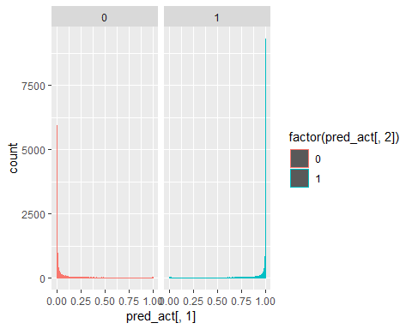

## [1] "Electron Efficiency: 0.900002044111936"  
## [1] "Pion Efficiency: 0.0623249729155169"

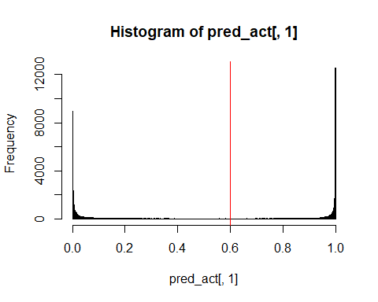

## Confusion Matrix and Statistics  
##   
## Reference  
## Prediction 0 1  
## 0 45872 4892  
## 1 3049 44029  
##   
## Accuracy : 0.9188   
## 95% CI : (0.9171, 0.9205)  
## No Information Rate : 0.5   
## P-Value [Acc > NIR] : < 2.2e-16   
##   
## Kappa : 0.8377   
##   
## Mcnemar's Test P-Value : < 2.2e-16   
##   
## Sensitivity : 0.9377   
## Specificity : 0.9000   
## Pos Pred Value : 0.9036   
## Neg Pred Value : 0.9352   
## Prevalence : 0.5000   
## Detection Rate : 0.4688   
## Detection Prevalence : 0.5188   
## Balanced Accuracy : 0.9188   
##   
## 'Positive' Class : 0   
##   
## [1] "--------------------------------------------------------------------------------------------------"  
## [1] "--------------------------------------------------------------------------------------------------"  
## [1] "model2"  
## [1] "--------------------------------------------------------------------------------------------------"

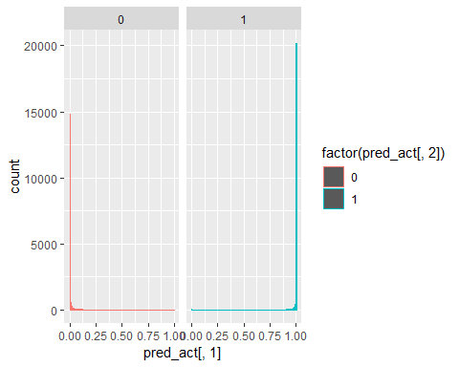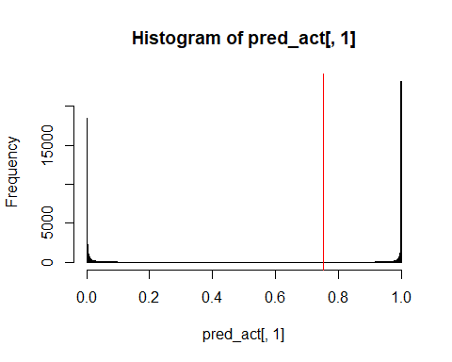

## [1] "Electron Efficiency: 0.900104249708714"  
## [1] "Pion Efficiency: 0.0298235931399603"  
## Confusion Matrix and Statistics  
##   
## Reference  
## Prediction 0 1  
## 0 47462 4887  
## 1 1459 44034  
##   
## Accuracy : 0.9351   
## 95% CI : (0.9336, 0.9367)  
## No Information Rate : 0.5   
## P-Value [Acc > NIR] : < 2.2e-16   
##   
## Kappa : 0.8703   
##   
## Mcnemar's Test P-Value : < 2.2e-16   
##   
## Sensitivity : 0.9702   
## Specificity : 0.9001   
## Pos Pred Value : 0.9066   
## Neg Pred Value : 0.9679   
## Prevalence : 0.5000   
## Detection Rate : 0.4851   
## Detection Prevalence : 0.5350   
## Balanced Accuracy : 0.9351   
##   
## 'Positive' Class : 0   
##   
## [1] "--------------------------------------------------------------------------------------------------"  
## [1] "--------------------------------------------------------------------------------------------------"  
## [1] "model3"  
## [1] "--------------------------------------------------------------------------------------------------"

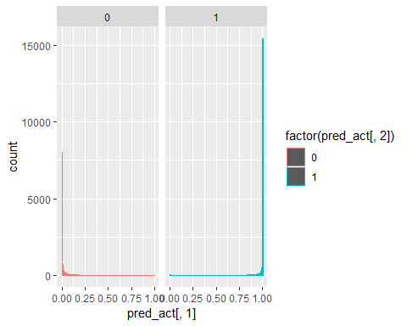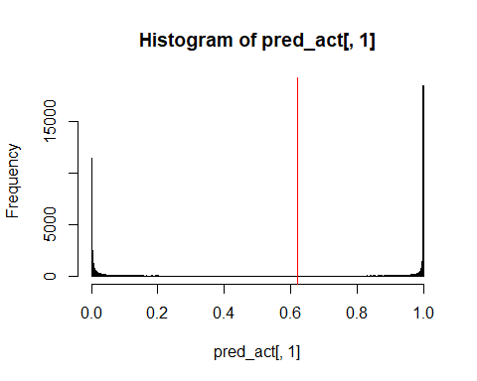

## [1] "Electron Efficiency: 0.900022485231291"  
## [1] "Pion Efficiency: 0.0534739682345005"  
## Confusion Matrix and Statistics  
##   
## Reference  
## Prediction 0 1  
## 0 46305 4891  
## 1 2616 44030  
##   
## Accuracy : 0.9233   
## 95% CI : (0.9216, 0.9249)  
## No Information Rate : 0.5   
## P-Value [Acc > NIR] : < 2.2e-16   
##   
## Kappa : 0.8465   
##   
## Mcnemar's Test P-Value : < 2.2e-16   
##   
## Sensitivity : 0.9465   
## Specificity : 0.9000   
## Pos Pred Value : 0.9045   
## Neg Pred Value : 0.9439   
## Prevalence : 0.5000   
## Detection Rate : 0.4733   
## Detection Prevalence : 0.5233   
## Balanced Accuracy : 0.9233   
##   
## 'Positive' Class : 0   
##   
## [1] "--------------------------------------------------------------------------------------------------"  
## [1] "--------------------------------------------------------------------------------------------------"  
## [1] "model4"  
## [1] "--------------------------------------------------------------------------------------------------"

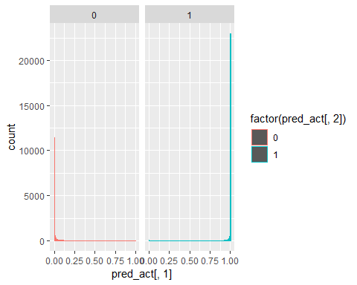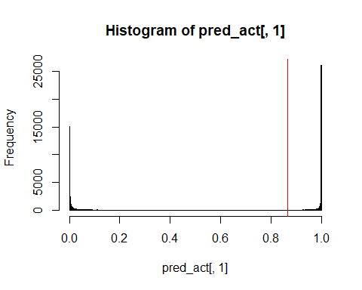

## [1] "Electron Efficiency: 0.89998160299258"  
## [1] "Pion Efficiency: 0.0222399378589972"  
## Confusion Matrix and Statistics  
##   
## Reference  
## Prediction 0 1  
## 0 47833 4893  
## 1 1088 44028  
##   
## Accuracy : 0.9389   
## 95% CI : (0.9374, 0.9404)  
## No Information Rate : 0.5   
## P-Value [Acc > NIR] : < 2.2e-16   
##   
## Kappa : 0.8777   
##   
## Mcnemar's Test P-Value : < 2.2e-16   
##   
## Sensitivity : 0.9778   
## Specificity : 0.9000   
## Pos Pred Value : 0.9072   
## Neg Pred Value : 0.9759   
## Prevalence : 0.5000   
## Detection Rate : 0.4889   
## Detection Prevalence : 0.5389   
## Balanced Accuracy : 0.9389   
##   
## 'Positive' Class : 0   
##   
## [1] "--------------------------------------------------------------------------------------------------"  
## [1] "--------------------------------------------------------------------------------------------------"  
## [1] "model5"  
## [1] "--------------------------------------------------------------------------------------------------"

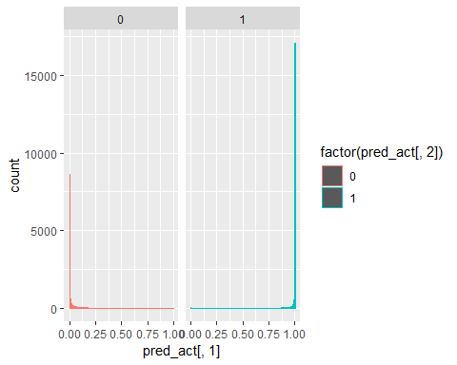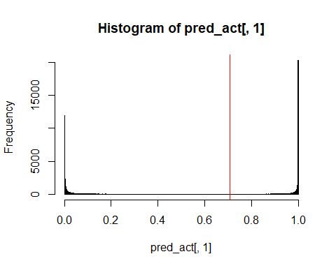

## [1] "Electron Efficiency: 0.899961161873224"  
## [1] "Pion Efficiency: 0.0556816091249157"  
## Confusion Matrix and Statistics  
##   
## Reference  
## Prediction 0 1  
## 0 46197 4894  
## 1 2724 44027  
##   
## Accuracy : 0.9221   
## 95% CI : (0.9204, 0.9238)  
## No Information Rate : 0.5   
## P-Value [Acc > NIR] : < 2.2e-16   
##   
## Kappa : 0.8443   
##   
## Mcnemar's Test P-Value : < 2.2e-16   
##   
## Sensitivity : 0.9443   
## Specificity : 0.9000   
## Pos Pred Value : 0.9042   
## Neg Pred Value : 0.9417   
## Prevalence : 0.5000   
## Detection Rate : 0.4722   
## Detection Prevalence : 0.5222   
## Balanced Accuracy : 0.9221   
##   
## 'Positive' Class : 0   
##   
## [1] "--------------------------------------------------------------------------------------------------"  
## [1] "--------------------------------------------------------------------------------------------------"  
## [1] "model6"  
## [1] "--------------------------------------------------------------------------------------------------"

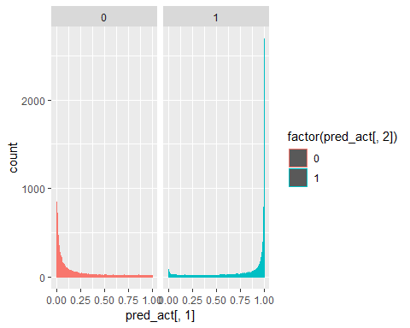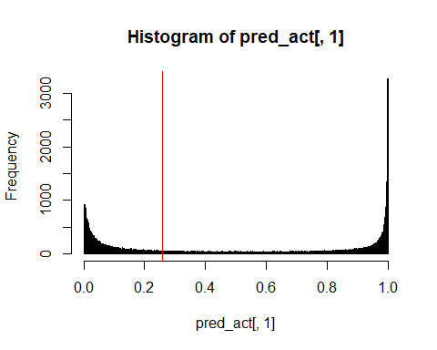

## [1] "Electron Efficiency: 0.900002044111936"  
## [1] "Pion Efficiency: 0.255432227468776"  
## Confusion Matrix and Statistics  
##   
## Reference  
## Prediction 0 1  
## 0 36425 4892  
## 1 12496 44029  
##   
## Accuracy : 0.8223   
## 95% CI : (0.8199, 0.8247)  
## No Information Rate : 0.5   
## P-Value [Acc > NIR] : < 2.2e-16   
##   
## Kappa : 0.6446   
##   
## Mcnemar's Test P-Value : < 2.2e-16   
##   
## Sensitivity : 0.7446   
## Specificity : 0.9000   
## Pos Pred Value : 0.8816   
## Neg Pred Value : 0.7789   
## Prevalence : 0.5000   
## Detection Rate : 0.3723   
## Detection Prevalence : 0.4223   
## Balanced Accuracy : 0.8223   
##   
## 'Positive' Class : 0   
##   
## [1] "--------------------------------------------------------------------------------------------------"  
## [1] "--------------------------------------------------------------------------------------------------"  
## [1] "model7"  
## [1] "--------------------------------------------------------------------------------------------------"

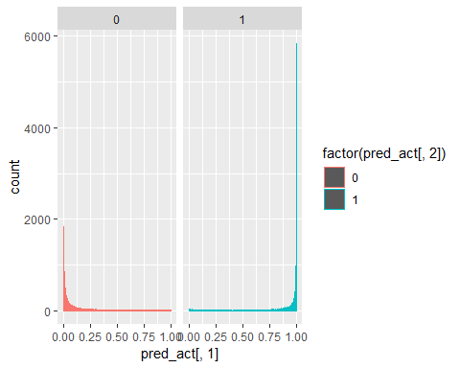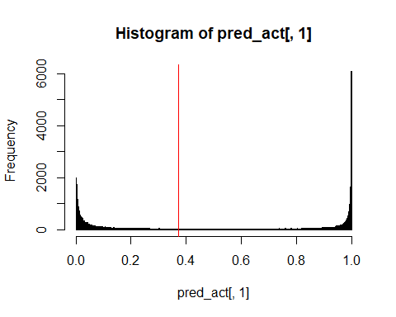

## [1] "Electron Efficiency: 0.900002044111936"  
## [1] "Pion Efficiency: 0.157744118067905"  
## Confusion Matrix and Statistics  
##   
## Reference  
## Prediction 0 1  
## 0 41204 4892  
## 1 7717 44029  
##   
## Accuracy : 0.8711   
## 95% CI : (0.869, 0.8732)  
## No Information Rate : 0.5   
## P-Value [Acc > NIR] : < 2.2e-16   
##   
## Kappa : 0.7423   
##   
## Mcnemar's Test P-Value : < 2.2e-16   
##   
## Sensitivity : 0.8423   
## Specificity : 0.9000   
## Pos Pred Value : 0.8939   
## Neg Pred Value : 0.8509   
## Prevalence : 0.5000   
## Detection Rate : 0.4211   
## Detection Prevalence : 0.4711   
## Balanced Accuracy : 0.8711   
##   
## 'Positive' Class : 0   
##   
## [1] "--------------------------------------------------------------------------------------------------"  
## [1] "--------------------------------------------------------------------------------------------------"  
## [1] "model8"  
## [1] "--------------------------------------------------------------------------------------------------"

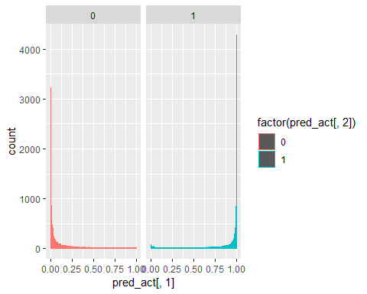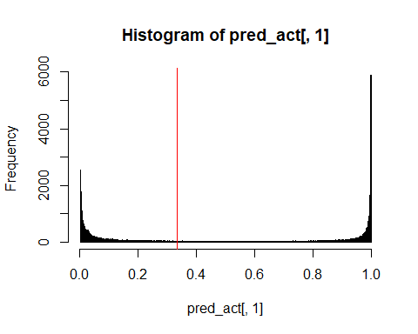

## [1] "Electron Efficiency: 0.900002044111936"  
## [1] "Pion Efficiency: 0.16375380715848"  
## Confusion Matrix and Statistics  
##   
## Reference  
## Prediction 0 1  
## 0 40910 4892  
## 1 8011 44029  
##   
## Accuracy : 0.8681   
## 95% CI : (0.866, 0.8702)  
## No Information Rate : 0.5   
## P-Value [Acc > NIR] : < 2.2e-16   
##   
## Kappa : 0.7362   
##   
## Mcnemar's Test P-Value : < 2.2e-16   
##   
## Sensitivity : 0.8362   
## Specificity : 0.9000   
## Pos Pred Value : 0.8932   
## Neg Pred Value : 0.8461   
## Prevalence : 0.5000   
## Detection Rate : 0.4181   
## Detection Prevalence : 0.4681   
## Balanced Accuracy : 0.8681   
##   
## 'Positive' Class : 0   
##   
## [1] "--------------------------------------------------------------------------------------------------"  
## [1] "--------------------------------------------------------------------------------------------------"  
## [1] "model9"  
## [1] "--------------------------------------------------------------------------------------------------"

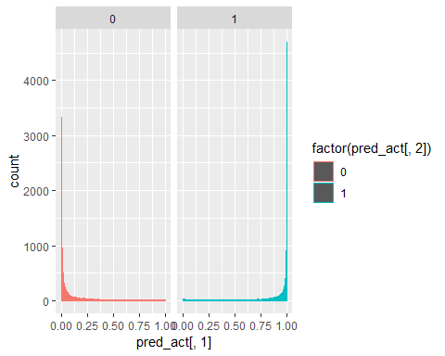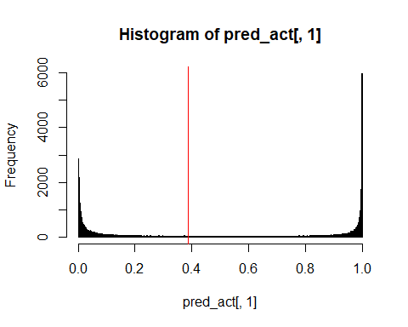

## [1] "Electron Efficiency: 0.900002044111936"  
## [1] "Pion Efficiency: 0.133541832750761"  
## Confusion Matrix and Statistics  
##   
## Reference  
## Prediction 0 1  
## 0 42388 4892  
## 1 6533 44029  
##   
## Accuracy : 0.8832   
## 95% CI : (0.8812, 0.8852)  
## No Information Rate : 0.5   
## P-Value [Acc > NIR] : < 2.2e-16   
##   
## Kappa : 0.7665   
##   
## Mcnemar's Test P-Value : < 2.2e-16   
##   
## Sensitivity : 0.8665   
## Specificity : 0.9000   
## Pos Pred Value : 0.8965   
## Neg Pred Value : 0.8708   
## Prevalence : 0.5000   
## Detection Rate : 0.4332   
## Detection Prevalence : 0.4832   
## Balanced Accuracy : 0.8832   
##   
## 'Positive' Class : 0   
##   
## [1] "--------------------------------------------------------------------------------------------------"  
## [1] "--------------------------------------------------------------------------------------------------"  
## [1] "model10"  
## [1] "--------------------------------------------------------------------------------------------------"

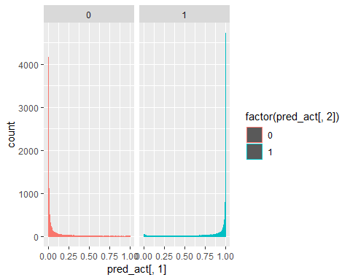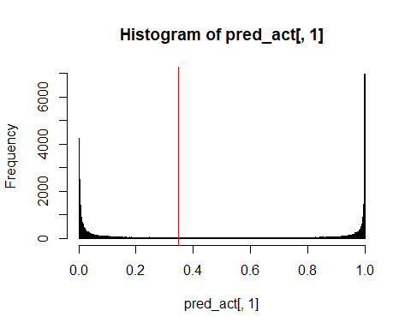

## [1] "Electron Efficiency: 0.899940720753868"  
## [1] "Pion Efficiency: 0.112323950859549"  
## Confusion Matrix and Statistics  
##   
## Reference  
## Prediction 0 1  
## 0 43426 4895  
## 1 5495 44026  
##   
## Accuracy : 0.8938   
## 95% CI : (0.8919, 0.8957)  
## No Information Rate : 0.5   
## P-Value [Acc > NIR] : < 2.2e-16   
##   
## Kappa : 0.7876   
##   
## Mcnemar's Test P-Value : 4.19e-09   
##   
## Sensitivity : 0.8877   
## Specificity : 0.8999   
## Pos Pred Value : 0.8987   
## Neg Pred Value : 0.8890   
## Prevalence : 0.5000   
## Detection Rate : 0.4438   
## Detection Prevalence : 0.4939   
## Balanced Accuracy : 0.8938   
##   
## 'Positive' Class : 0   
##   
## [1] "--------------------------------------------------------------------------------------------------"  
## [1] "--------------------------------------------------------------------------------------------------"  
## [1] "model11"  
## [1] "--------------------------------------------------------------------------------------------------"

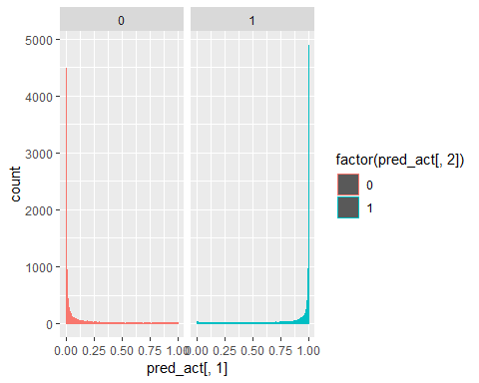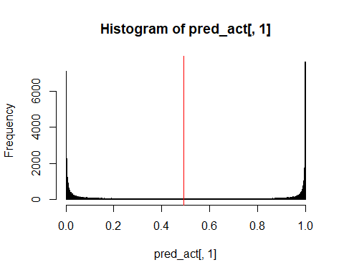

## [1] "Electron Efficiency: 0.900083808589358"  
## [1] "Pion Efficiency: 0.0856074078616545"  
## Confusion Matrix and Statistics  
##   
## Reference  
## Prediction 0 1  
## 0 44733 4888  
## 1 4188 44033  
##   
## Accuracy : 0.9072   
## 95% CI : (0.9054, 0.909)  
## No Information Rate : 0.5   
## P-Value [Acc > NIR] : < 2.2e-16   
##   
## Kappa : 0.8145   
##   
## Mcnemar's Test P-Value : 2.181e-13   
##   
## Sensitivity : 0.9144   
## Specificity : 0.9001   
## Pos Pred Value : 0.9015   
## Neg Pred Value : 0.9131   
## Prevalence : 0.5000   
## Detection Rate : 0.4572   
## Detection Prevalence : 0.5072   
## Balanced Accuracy : 0.9072   
##   
## 'Positive' Class : 0   
##   
## [1] "--------------------------------------------------------------------------------------------------"  
## [1] "--------------------------------------------------------------------------------------------------"  
## [1] "model12"  
## [1] "--------------------------------------------------------------------------------------------------"

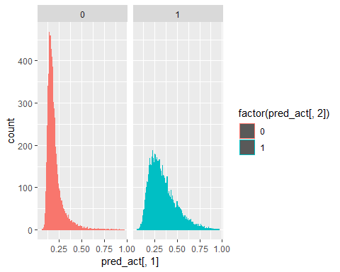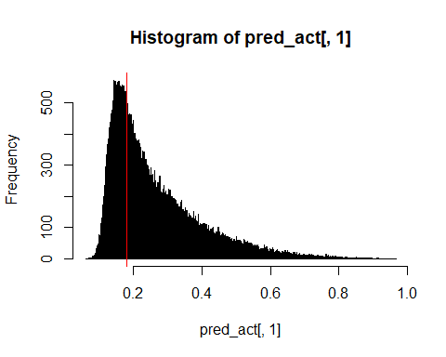

## [1] "Electron Efficiency: 0.899818074037734"  
## [1] "Pion Efficiency: 0.41783692074978"  
## Confusion Matrix and Statistics  
##   
## Reference  
## Prediction 0 1  
## 0 28480 4901  
## 1 20441 44020  
##   
## Accuracy : 0.741   
## 95% CI : (0.7382, 0.7437)  
## No Information Rate : 0.5   
## P-Value [Acc > NIR] : < 2.2e-16   
##   
## Kappa : 0.482   
##   
## Mcnemar's Test P-Value : < 2.2e-16   
##   
## Sensitivity : 0.5822   
## Specificity : 0.8998   
## Pos Pred Value : 0.8532   
## Neg Pred Value : 0.6829   
## Prevalence : 0.5000   
## Detection Rate : 0.2911   
## Detection Prevalence : 0.3412   
## Balanced Accuracy : 0.7410   
##   
## 'Positive' Class : 0   
##   
## [1] "--------------------------------------------------------------------------------------------------"  
## [1] "--------------------------------------------------------------------------------------------------"  
## [1] "model13"  
## [1] "--------------------------------------------------------------------------------------------------"

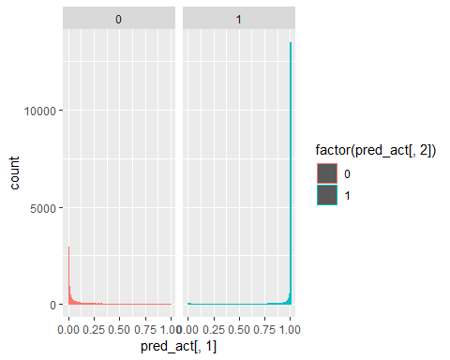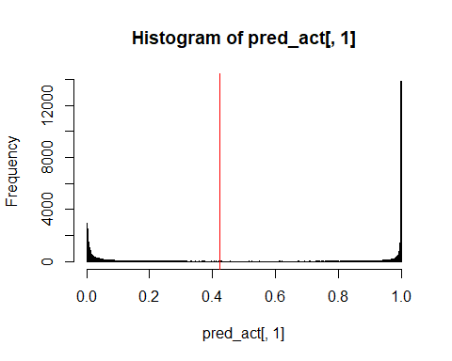

## [1] "Electron Efficiency: 0.899940720753868"  
## [1] "Pion Efficiency: 0.100345454917111"  
## Confusion Matrix and Statistics  
##   
## Reference  
## Prediction 0 1  
## 0 44012 4895  
## 1 4909 44026  
##   
## Accuracy : 0.8998   
## 95% CI : (0.8979, 0.9017)  
## No Information Rate : 0.5   
## P-Value [Acc > NIR] : <2e-16   
##   
## Kappa : 0.7996   
##   
## Mcnemar's Test P-Value : 0.8955   
##   
## Sensitivity : 0.8997   
## Specificity : 0.8999   
## Pos Pred Value : 0.8999   
## Neg Pred Value : 0.8997   
## Prevalence : 0.5000   
## Detection Rate : 0.4498   
## Detection Prevalence : 0.4999   
## Balanced Accuracy : 0.8998   
##   
## 'Positive' Class : 0   
##   
## [1] "--------------------------------------------------------------------------------------------------"  
## [1] "--------------------------------------------------------------------------------------------------"  
## [1] "model14"  
## [1] "--------------------------------------------------------------------------------------------------"

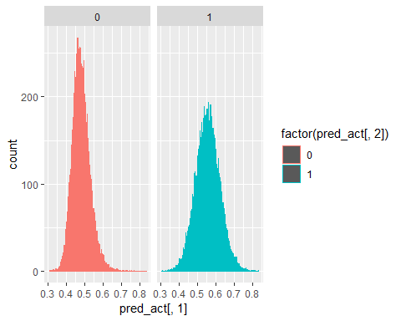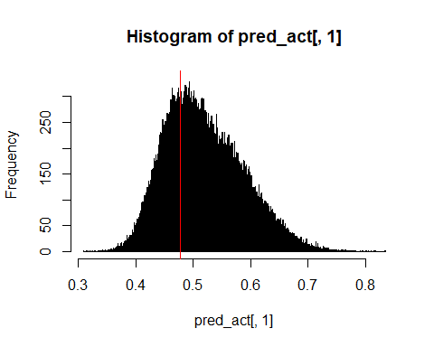

## [1] "Electron Efficiency: 0.900002044111936"  
## [1] "Pion Efficiency: 0.488501870362421"  
## Confusion Matrix and Statistics  
##   
## Reference  
## Prediction 0 1  
## 0 25023 4892  
## 1 23898 44029  
##   
## Accuracy : 0.7058   
## 95% CI : (0.7029, 0.7086)  
## No Information Rate : 0.5   
## P-Value [Acc > NIR] : < 2.2e-16   
##   
## Kappa : 0.4115   
##   
## Mcnemar's Test P-Value : < 2.2e-16   
##   
## Sensitivity : 0.5115   
## Specificity : 0.9000   
## Pos Pred Value : 0.8365   
## Neg Pred Value : 0.6482   
## Prevalence : 0.5000   
## Detection Rate : 0.2557   
## Detection Prevalence : 0.3057   
## Balanced Accuracy : 0.7058   
##   
## 'Positive' Class : 0   
##   
## [1] "--------------------------------------------------------------------------------------------------"  
## [1] "--------------------------------------------------------------------------------------------------"  
## [1] "model15"  
## [1] "--------------------------------------------------------------------------------------------------"

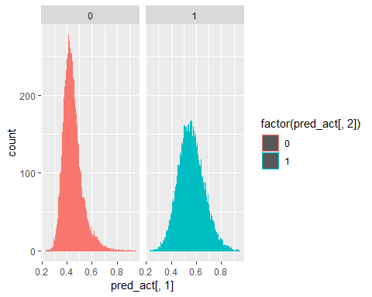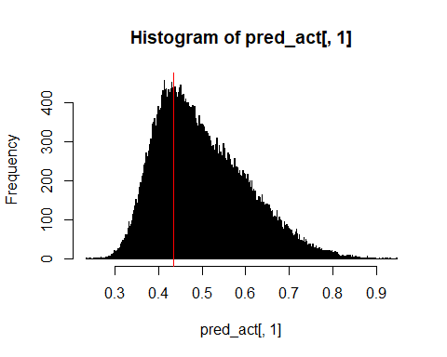

## [1] "Electron Efficiency: 0.900002044111936"  
## [1] "Pion Efficiency: 0.474111322336011"  
## Confusion Matrix and Statistics  
##   
## Reference  
## Prediction 0 1  
## 0 25727 4892  
## 1 23194 44029  
##   
## Accuracy : 0.7129   
## 95% CI : (0.7101, 0.7158)  
## No Information Rate : 0.5   
## P-Value [Acc > NIR] : < 2.2e-16   
##   
## Kappa : 0.4259   
##   
## Mcnemar's Test P-Value : < 2.2e-16   
##   
## Sensitivity : 0.5259   
## Specificity : 0.9000   
## Pos Pred Value : 0.8402   
## Neg Pred Value : 0.6550   
## Prevalence : 0.5000   
## Detection Rate : 0.2629   
## Detection Prevalence : 0.3129   
## Balanced Accuracy : 0.7129   
##   
## 'Positive' Class : 0   
##   
## [1] "--------------------------------------------------------------------------------------------------"  
## [1] "--------------------------------------------------------------------------------------------------"  
## [1] "model16"  
## [1] "--------------------------------------------------------------------------------------------------"

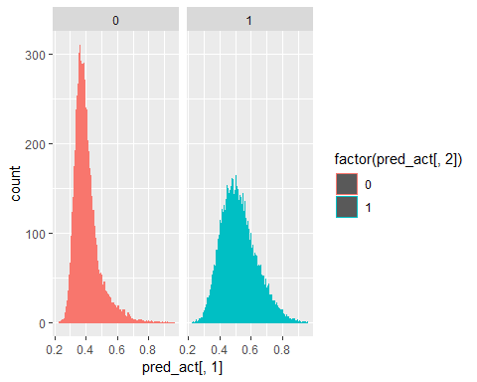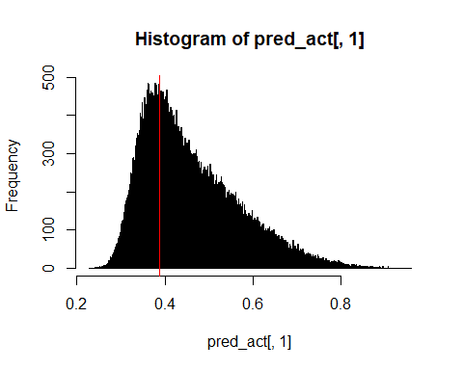

## [1] "Electron Efficiency: 0.89998160299258"  
## [1] "Pion Efficiency: 0.462991353406513"  
## Confusion Matrix and Statistics  
##   
## Reference  
## Prediction 0 1  
## 0 26271 4893  
## 1 22650 44028  
##   
## Accuracy : 0.7185   
## 95% CI : (0.7157, 0.7213)  
## No Information Rate : 0.5   
## P-Value [Acc > NIR] : < 2.2e-16   
##   
## Kappa : 0.437   
##   
## Mcnemar's Test P-Value : < 2.2e-16   
##   
## Sensitivity : 0.5370   
## Specificity : 0.9000   
## Pos Pred Value : 0.8430   
## Neg Pred Value : 0.6603   
## Prevalence : 0.5000   
## Detection Rate : 0.2685   
## Detection Prevalence : 0.3185   
## Balanced Accuracy : 0.7185   
##   
## 'Positive' Class : 0   
##   
## [1] "--------------------------------------------------------------------------------------------------"  
## [1] "--------------------------------------------------------------------------------------------------"  
## [1] "model17"  
## [1] "--------------------------------------------------------------------------------------------------"

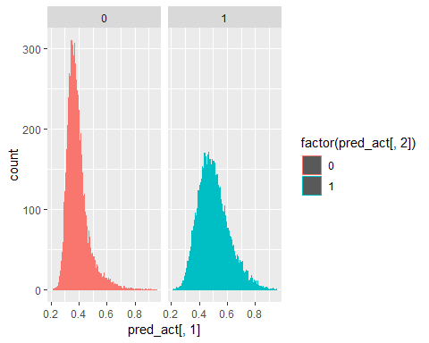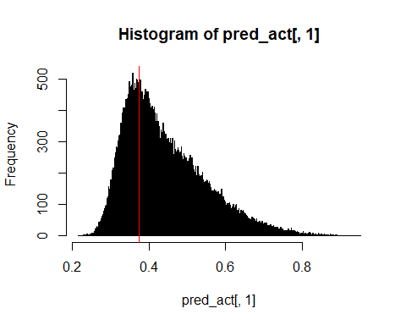

## [1] "Electron Efficiency: 0.900002044111936"  
## [1] "Pion Efficiency: 0.473804705545676"  
## Confusion Matrix and Statistics  
##   
## Reference  
## Prediction 0 1  
## 0 25742 4892  
## 1 23179 44029  
##   
## Accuracy : 0.7131   
## 95% CI : (0.7103, 0.7159)  
## No Information Rate : 0.5   
## P-Value [Acc > NIR] : < 2.2e-16   
##   
## Kappa : 0.4262   
##   
## Mcnemar's Test P-Value : < 2.2e-16   
##   
## Sensitivity : 0.5262   
## Specificity : 0.9000   
## Pos Pred Value : 0.8403   
## Neg Pred Value : 0.6551   
## Prevalence : 0.5000   
## Detection Rate : 0.2631   
## Detection Prevalence : 0.3131   
## Balanced Accuracy : 0.7131   
##   
## 'Positive' Class : 0   
##   
## [1] "--------------------------------------------------------------------------------------------------"  
## [1] "--------------------------------------------------------------------------------------------------"  
## [1] "model18"  
## [1] "--------------------------------------------------------------------------------------------------"

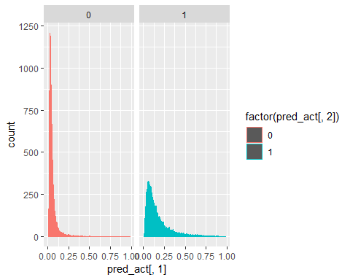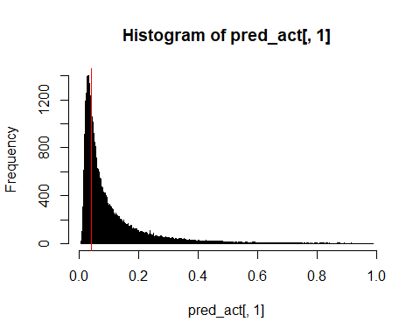

## [1] "Electron Efficiency: 0.899961161873224"  
## [1] "Pion Efficiency: 0.44220273502177"  
## Confusion Matrix and Statistics  
##   
## Reference  
## Prediction 0 1  
## 0 27288 4894  
## 1 21633 44027  
##   
## Accuracy : 0.7289   
## 95% CI : (0.7261, 0.7317)  
## No Information Rate : 0.5   
## P-Value [Acc > NIR] : < 2.2e-16   
##   
## Kappa : 0.4578   
##   
## Mcnemar's Test P-Value : < 2.2e-16   
##   
## Sensitivity : 0.5578   
## Specificity : 0.9000   
## Pos Pred Value : 0.8479   
## Neg Pred Value : 0.6705   
## Prevalence : 0.5000   
## Detection Rate : 0.2789   
## Detection Prevalence : 0.3289   
## Balanced Accuracy : 0.7289   
##   
## 'Positive' Class : 0   
##   
## [1] "--------------------------------------------------------------------------------------------------"  
## [1] "--------------------------------------------------------------------------------------------------"  
## [1] "model19"  
## [1] "--------------------------------------------------------------------------------------------------"

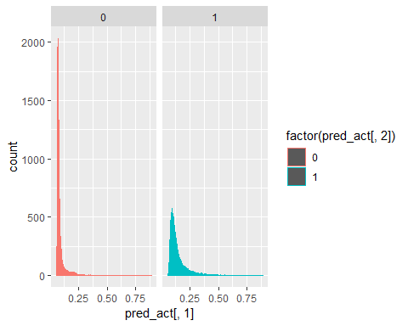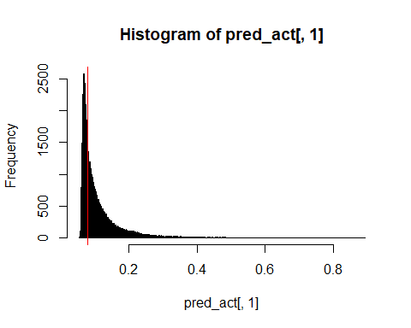

## [1] "Electron Efficiency: 0.89998160299258"  
## [1] "Pion Efficiency: 0.319085873142413"  
## Confusion Matrix and Statistics  
##   
## Reference  
## Prediction 0 1  
## 0 33311 4893  
## 1 15610 44028  
##   
## Accuracy : 0.7904   
## 95% CI : (0.7879, 0.793)  
## No Information Rate : 0.5   
## P-Value [Acc > NIR] : < 2.2e-16   
##   
## Kappa : 0.5809   
##   
## Mcnemar's Test P-Value : < 2.2e-16   
##   
## Sensitivity : 0.6809   
## Specificity : 0.9000   
## Pos Pred Value : 0.8719   
## Neg Pred Value : 0.7383   
## Prevalence : 0.5000   
## Detection Rate : 0.3405   
## Detection Prevalence : 0.3905   
## Balanced Accuracy : 0.7904   
##   
## 'Positive' Class : 0   
##   
## [1] "--------------------------------------------------------------------------------------------------"  
## [1] "--------------------------------------------------------------------------------------------------"  
## [1] "model20"  
## [1] "--------------------------------------------------------------------------------------------------"

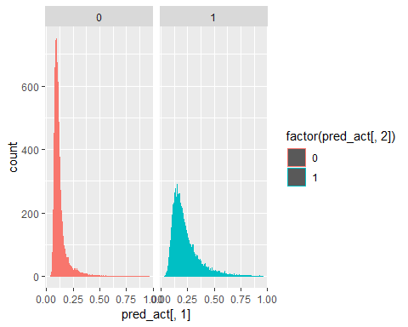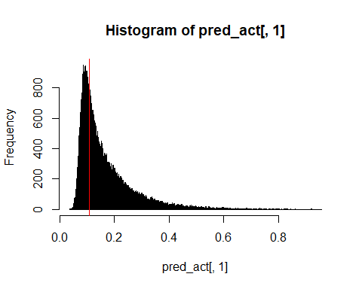

## [1] "Electron Efficiency: 0.900022485231291"  
## [1] "Pion Efficiency: 0.400461969297439"  
## Confusion Matrix and Statistics  
##   
## Reference  
## Prediction 0 1  
## 0 29330 4891  
## 1 19591 44030  
##   
## Accuracy : 0.7498   
## 95% CI : (0.7471, 0.7525)  
## No Information Rate : 0.5   
## P-Value [Acc > NIR] : < 2.2e-16   
##   
## Kappa : 0.4996   
##   
## Mcnemar's Test P-Value : < 2.2e-16   
##   
## Sensitivity : 0.5995   
## Specificity : 0.9000   
## Pos Pred Value : 0.8571   
## Neg Pred Value : 0.6921   
## Prevalence : 0.5000   
## Detection Rate : 0.2998   
## Detection Prevalence : 0.3498   
## Balanced Accuracy : 0.7498   
##   
## 'Positive' Class : 0   
##   
## [1] "--------------------------------------------------------------------------------------------------"  
## [1] "--------------------------------------------------------------------------------------------------"  
## [1] "model21"  
## [1] "--------------------------------------------------------------------------------------------------"

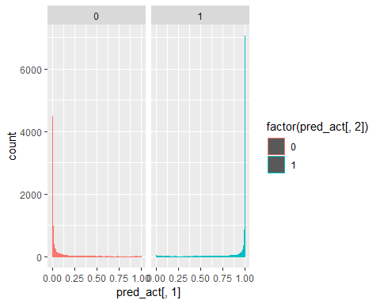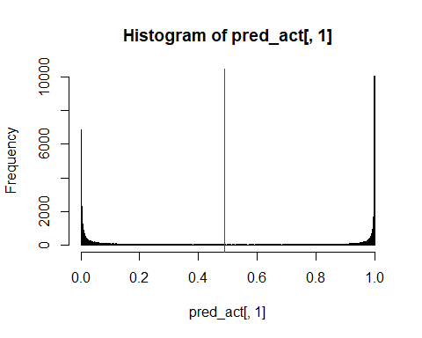

## [1] "Electron Efficiency: 0.900063367470003"  
## [1] "Pion Efficiency: 0.086915639500419"  
## Confusion Matrix and Statistics  
##   
## Reference  
## Prediction 0 1  
## 0 44669 4889  
## 1 4252 44032  
##   
## Accuracy : 0.9066   
## 95% CI : (0.9047, 0.9084)  
## No Information Rate : 0.5   
## P-Value [Acc > NIR] : < 2.2e-16   
##   
## Kappa : 0.8131   
##   
## Mcnemar's Test P-Value : 2.889e-11   
##   
## Sensitivity : 0.9131   
## Specificity : 0.9001   
## Pos Pred Value : 0.9013   
## Neg Pred Value : 0.9119   
## Prevalence : 0.5000   
## Detection Rate : 0.4565   
## Detection Prevalence : 0.5065   
## Balanced Accuracy : 0.9066   
##   
## 'Positive' Class : 0   
##   
## [1] "--------------------------------------------------------------------------------------------------"  
## [1] "--------------------------------------------------------------------------------------------------"  
## [1] "model22"  
## [1] "--------------------------------------------------------------------------------------------------"

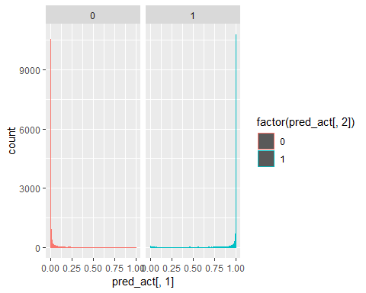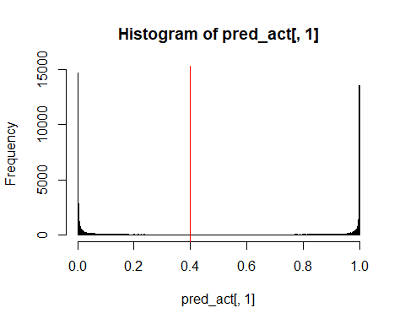

## [1] "Electron Efficiency: 0.900063367470003"  
## [1] "Pion Efficiency: 0.057071605241103"  
## Confusion Matrix and Statistics  
##   
## Reference  
## Prediction 0 1  
## 0 46129 4889  
## 1 2792 44032  
##   
## Accuracy : 0.9215   
## 95% CI : (0.9198, 0.9232)  
## No Information Rate : 0.5   
## P-Value [Acc > NIR] : < 2.2e-16   
##   
## Kappa : 0.843   
##   
## Mcnemar's Test P-Value : < 2.2e-16   
##   
## Sensitivity : 0.9429   
## Specificity : 0.9001   
## Pos Pred Value : 0.9042   
## Neg Pred Value : 0.9404   
## Prevalence : 0.5000   
## Detection Rate : 0.4715   
## Detection Prevalence : 0.5214   
## Balanced Accuracy : 0.9215   
##   
## 'Positive' Class : 0   
##   
## [1] "--------------------------------------------------------------------------------------------------"  
## [1] "--------------------------------------------------------------------------------------------------"  
## [1] "model23"  
## [1] "--------------------------------------------------------------------------------------------------"

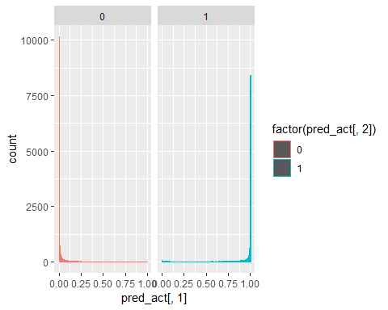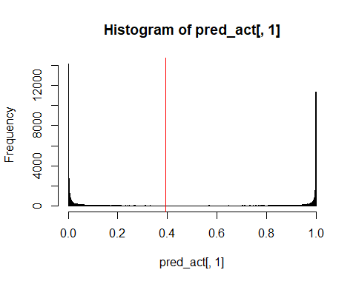

## [1] "Electron Efficiency: 0.900002044111936"  
## [1] "Pion Efficiency: 0.0645530549252877"  
## Confusion Matrix and Statistics  
##   
## Reference  
## Prediction 0 1  
## 0 45763 4892  
## 1 3158 44029  
##   
## Accuracy : 0.9177   
## 95% CI : (0.916, 0.9194)  
## No Information Rate : 0.5   
## P-Value [Acc > NIR] : < 2.2e-16   
##   
## Kappa : 0.8354   
##   
## Mcnemar's Test P-Value : < 2.2e-16   
##   
## Sensitivity : 0.9354   
## Specificity : 0.9000   
## Pos Pred Value : 0.9034   
## Neg Pred Value : 0.9331   
## Prevalence : 0.5000   
## Detection Rate : 0.4677   
## Detection Prevalence : 0.5177   
## Balanced Accuracy : 0.9177   
##   
## 'Positive' Class : 0   
##   
## [1] "--------------------------------------------------------------------------------------------------"  
## [1] "--------------------------------------------------------------------------------------------------"  
## [1] "model24"  
## [1] "--------------------------------------------------------------------------------------------------"

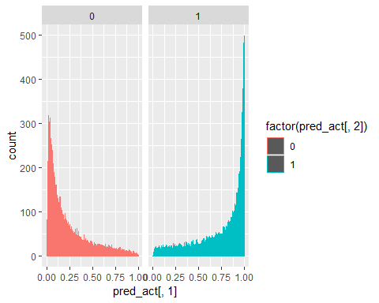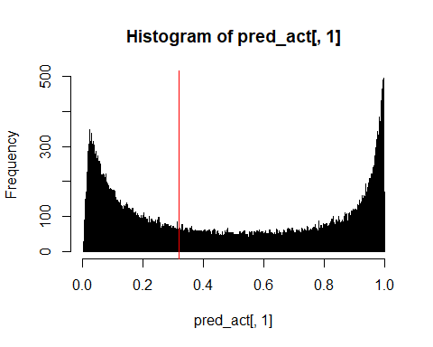

## [1] "Electron Efficiency: 0.900002044111936"  
## [1] "Pion Efficiency: 0.241143885039145"  
## Confusion Matrix and Statistics  
##   
## Reference  
## Prediction 0 1  
## 0 37124 4892  
## 1 11797 44029  
##   
## Accuracy : 0.8294   
## 95% CI : (0.8271, 0.8318)  
## No Information Rate : 0.5   
## P-Value [Acc > NIR] : < 2.2e-16   
##   
## Kappa : 0.6589   
##   
## Mcnemar's Test P-Value : < 2.2e-16   
##   
## Sensitivity : 0.7589   
## Specificity : 0.9000   
## Pos Pred Value : 0.8836   
## Neg Pred Value : 0.7887   
## Prevalence : 0.5000   
## Detection Rate : 0.3794   
## Detection Prevalence : 0.4294   
## Balanced Accuracy : 0.8294   
##   
## 'Positive' Class : 0   
##   
## [1] "--------------------------------------------------------------------------------------------------"  
## [1] "--------------------------------------------------------------------------------------------------"  
## [1] "model25"  
## [1] "--------------------------------------------------------------------------------------------------"

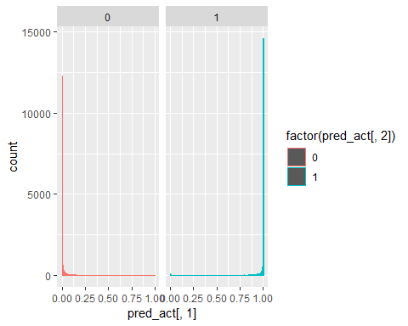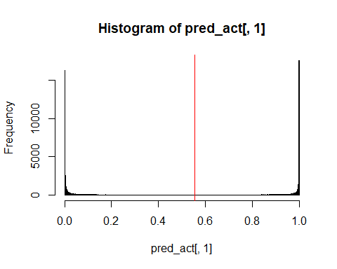

## [1] "Electron Efficiency: 0.900002044111936"  
## [1] "Pion Efficiency: 0.0451135504180209"  
## Confusion Matrix and Statistics  
##   
## Reference  
## Prediction 0 1  
## 0 46714 4892  
## 1 2207 44029  
##   
## Accuracy : 0.9274   
## 95% CI : (0.9258, 0.9291)  
## No Information Rate : 0.5   
## P-Value [Acc > NIR] : < 2.2e-16   
##   
## Kappa : 0.8549   
##   
## Mcnemar's Test P-Value : < 2.2e-16   
##   
## Sensitivity : 0.9549   
## Specificity : 0.9000   
## Pos Pred Value : 0.9052   
## Neg Pred Value : 0.9523   
## Prevalence : 0.5000   
## Detection Rate : 0.4774   
## Detection Prevalence : 0.5274   
## Balanced Accuracy : 0.9274   
##   
## 'Positive' Class : 0   
##   
## [1] "--------------------------------------------------------------------------------------------------"  
## [1] "--------------------------------------------------------------------------------------------------"  
## [1] "model25_1_1"  
## [1] "--------------------------------------------------------------------------------------------------"

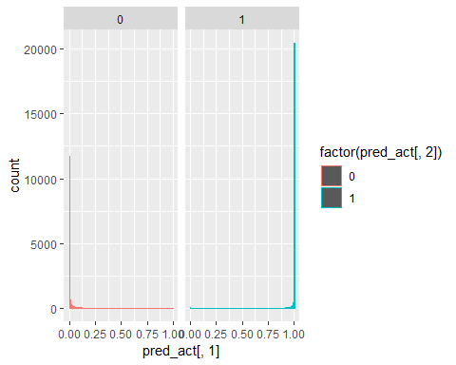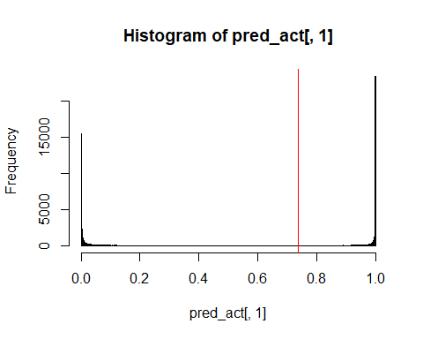

## [1] "Electron Efficiency: 0.900042926350647"  
## [1] "Pion Efficiency: 0.0387563622983995"  
## Confusion Matrix and Statistics  
##   
## Reference  
## Prediction 0 1  
## 0 47025 4890  
## 1 1896 44031  
##   
## Accuracy : 0.9306   
## 95% CI : (0.929, 0.9322)  
## No Information Rate : 0.5   
## P-Value [Acc > NIR] : < 2.2e-16   
##   
## Kappa : 0.8613   
##   
## Mcnemar's Test P-Value : < 2.2e-16   
##   
## Sensitivity : 0.9612   
## Specificity : 0.9000   
## Pos Pred Value : 0.9058   
## Neg Pred Value : 0.9587   
## Prevalence : 0.5000   
## Detection Rate : 0.4806   
## Detection Prevalence : 0.5306   
## Balanced Accuracy : 0.9306   
##   
## 'Positive' Class : 0   
##   
## [1] "--------------------------------------------------------------------------------------------------"  
## [1] "--------------------------------------------------------------------------------------------------"  
## [1] "model25_1_2"  
## [1] "--------------------------------------------------------------------------------------------------"

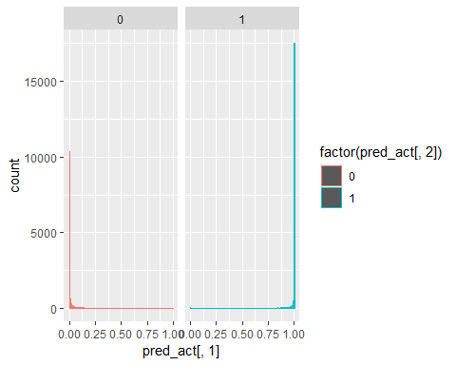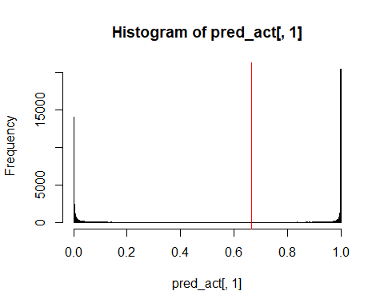

## [1] "Electron Efficiency: 0.900022485231291"  
## [1] "Pion Efficiency: 0.042415322663069"  
## Confusion Matrix and Statistics  
##   
## Reference  
## Prediction 0 1  
## 0 46846 4891  
## 1 2075 44030  
##   
## Accuracy : 0.9288   
## 95% CI : (0.9272, 0.9304)  
## No Information Rate : 0.5   
## P-Value [Acc > NIR] : < 2.2e-16   
##   
## Kappa : 0.8576   
##   
## Mcnemar's Test P-Value : < 2.2e-16   
##   
## Sensitivity : 0.9576   
## Specificity : 0.9000   
## Pos Pred Value : 0.9055   
## Neg Pred Value : 0.9550   
## Prevalence : 0.5000   
## Detection Rate : 0.4788   
## Detection Prevalence : 0.5288   
## Balanced Accuracy : 0.9288   
##   
## 'Positive' Class : 0   
##   
## [1] "--------------------------------------------------------------------------------------------------"  
## [1] "--------------------------------------------------------------------------------------------------"  
## [1] "model25_1_3"  
## [1] "--------------------------------------------------------------------------------------------------"

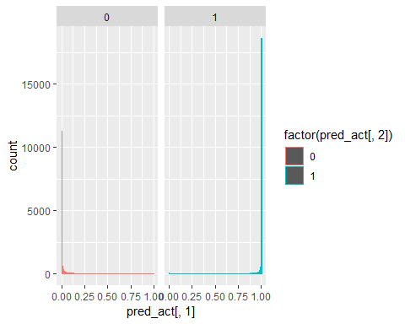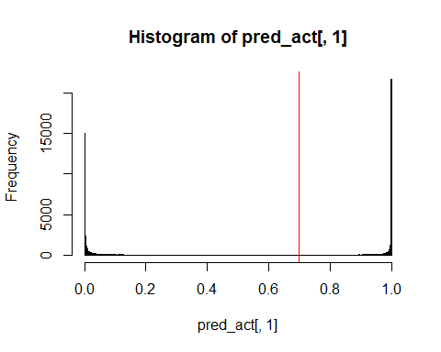

## [1] "Electron Efficiency: 0.900042926350647"  
## [1] "Pion Efficiency: 0.0425175282598475"  
## Confusion Matrix and Statistics  
##   
## Reference  
## Prediction 0 1  
## 0 46841 4890  
## 1 2080 44031  
##   
## Accuracy : 0.9288   
## 95% CI : (0.9271, 0.9304)  
## No Information Rate : 0.5   
## P-Value [Acc > NIR] : < 2.2e-16   
##   
## Kappa : 0.8575   
##   
## Mcnemar's Test P-Value : < 2.2e-16   
##   
## Sensitivity : 0.9575   
## Specificity : 0.9000   
## Pos Pred Value : 0.9055   
## Neg Pred Value : 0.9549   
## Prevalence : 0.5000   
## Detection Rate : 0.4787   
## Detection Prevalence : 0.5287   
## Balanced Accuracy : 0.9288   
##   
## 'Positive' Class : 0   
##   
## [1] "--------------------------------------------------------------------------------------------------"  
## [1] "--------------------------------------------------------------------------------------------------"  
## [1] "model25_1_4"  
## [1] "--------------------------------------------------------------------------------------------------"

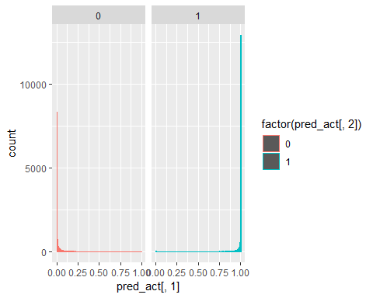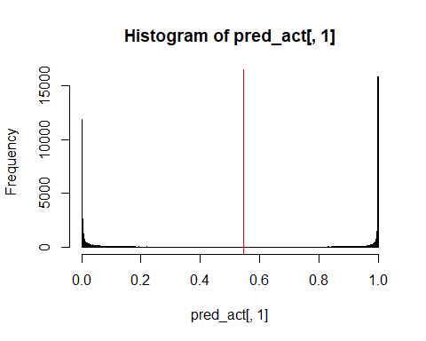

## [1] "Electron Efficiency: 0.900002044111936"  
## [1] "Pion Efficiency: 0.0496514789149854"  
## Confusion Matrix and Statistics  
##   
## Reference  
## Prediction 0 1  
## 0 46492 4892  
## 1 2429 44029  
##   
## Accuracy : 0.9252   
## 95% CI : (0.9235, 0.9268)  
## No Information Rate : 0.5   
## P-Value [Acc > NIR] : < 2.2e-16   
##   
## Kappa : 0.8504   
##   
## Mcnemar's Test P-Value : < 2.2e-16   
##   
## Sensitivity : 0.9503   
## Specificity : 0.9000   
## Pos Pred Value : 0.9048   
## Neg Pred Value : 0.9477   
## Prevalence : 0.5000   
## Detection Rate : 0.4752   
## Detection Prevalence : 0.5252   
## Balanced Accuracy : 0.9252   
##   
## 'Positive' Class : 0   
##   
## [1] "--------------------------------------------------------------------------------------------------"  
## [1] "--------------------------------------------------------------------------------------------------"  
## [1] "model25_1_5"  
## [1] "--------------------------------------------------------------------------------------------------"

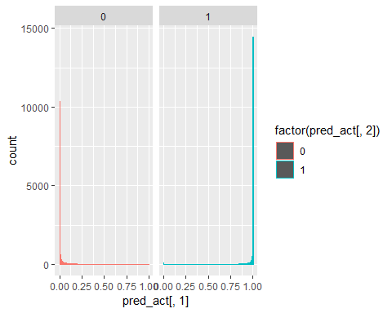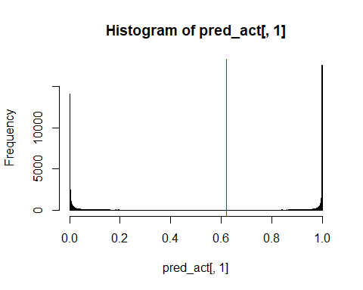

## [1] "Electron Efficiency: 0.900002044111936"  
## [1] "Pion Efficiency: 0.04288546840825"  
## Confusion Matrix and Statistics  
##   
## Reference  
## Prediction 0 1  
## 0 46823 4892  
## 1 2098 44029  
##   
## Accuracy : 0.9286   
## 95% CI : (0.9269, 0.9302)  
## No Information Rate : 0.5   
## P-Value [Acc > NIR] : < 2.2e-16   
##   
## Kappa : 0.8571   
##   
## Mcnemar's Test P-Value : < 2.2e-16   
##   
## Sensitivity : 0.9571   
## Specificity : 0.9000   
## Pos Pred Value : 0.9054   
## Neg Pred Value : 0.9545   
## Prevalence : 0.5000   
## Detection Rate : 0.4786   
## Detection Prevalence : 0.5286   
## Balanced Accuracy : 0.9286   
##   
## 'Positive' Class : 0   
##   
## [1] "--------------------------------------------------------------------------------------------------"  
## [1] "--------------------------------------------------------------------------------------------------"  
## [1] "model25_1_6"  
## [1] "--------------------------------------------------------------------------------------------------"

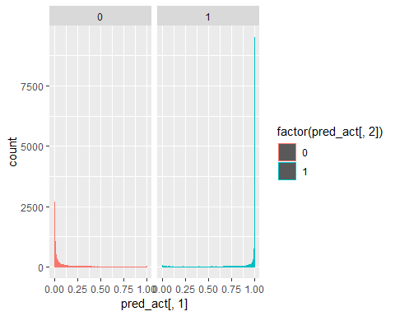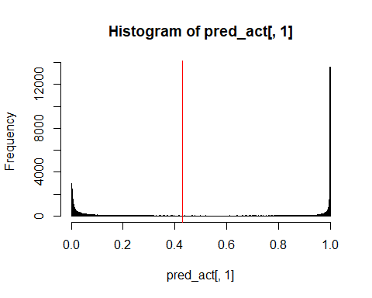

## [1] "Electron Efficiency: 0.900002044111936"  
## [1] "Pion Efficiency: 0.103043682672063"  
## Confusion Matrix and Statistics  
##   
## Reference  
## Prediction 0 1  
## 0 43880 4892  
## 1 5041 44029  
##   
## Accuracy : 0.8985   
## 95% CI : (0.8966, 0.9004)  
## No Information Rate : 0.5   
## P-Value [Acc > NIR] : <2e-16   
##   
## Kappa : 0.797   
##   
## Mcnemar's Test P-Value : 0.1375   
##   
## Sensitivity : 0.8970   
## Specificity : 0.9000   
## Pos Pred Value : 0.8997   
## Neg Pred Value : 0.8973   
## Prevalence : 0.5000   
## Detection Rate : 0.4485   
## Detection Prevalence : 0.4985   
## Balanced Accuracy : 0.8985   
##   
## 'Positive' Class : 0   
##   
## [1] "--------------------------------------------------------------------------------------------------"  
## [1] "--------------------------------------------------------------------------------------------------"  
## [1] "model25_1_7"  
## [1] "--------------------------------------------------------------------------------------------------"

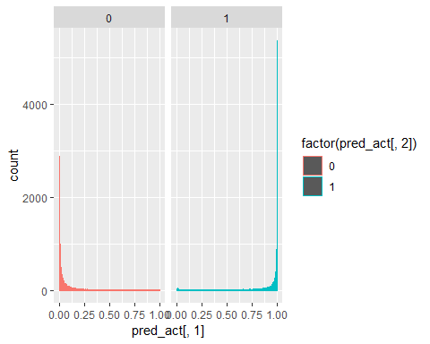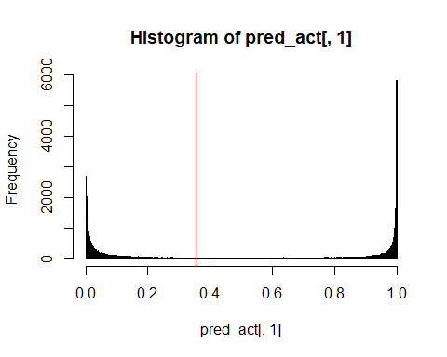

## [1] "Electron Efficiency: 0.900022485231291"  
## [1] "Pion Efficiency: 0.15625191635494"  
## Confusion Matrix and Statistics  
##   
## Reference  
## Prediction 0 1  
## 0 41277 4891  
## 1 7644 44030  
##   
## Accuracy : 0.8719   
## 95% CI : (0.8698, 0.874)  
## No Information Rate : 0.5   
## P-Value [Acc > NIR] : < 2.2e-16   
##   
## Kappa : 0.7438   
##   
## Mcnemar's Test P-Value : < 2.2e-16   
##   
## Sensitivity : 0.8437   
## Specificity : 0.9000   
## Pos Pred Value : 0.8941   
## Neg Pred Value : 0.8521   
## Prevalence : 0.5000   
## Detection Rate : 0.4219   
## Detection Prevalence : 0.4719   
## Balanced Accuracy : 0.8719   
##   
## 'Positive' Class : 0   
##   
## [1] "--------------------------------------------------------------------------------------------------"  
## [1] "--------------------------------------------------------------------------------------------------"  
## [1] "model25_1"  
## [1] "--------------------------------------------------------------------------------------------------"

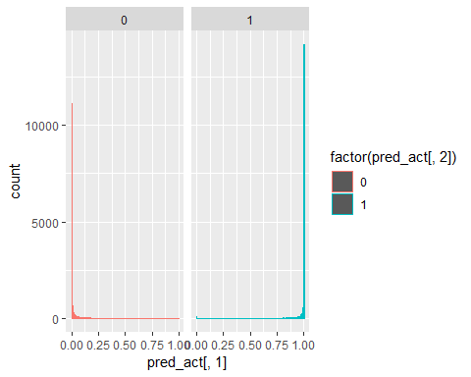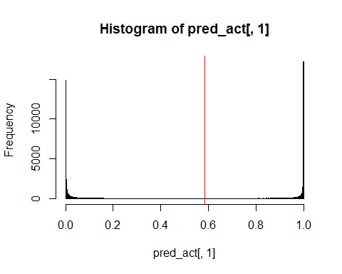

## [1] "Electron Efficiency: 0.89998160299258"  
## [1] "Pion Efficiency: 0.0453792849696449"  
## Confusion Matrix and Statistics  
##   
## Reference  
## Prediction 0 1  
## 0 46701 4893  
## 1 2220 44028  
##   
## Accuracy : 0.9273   
## 95% CI : (0.9257, 0.9289)  
## No Information Rate : 0.5   
## P-Value [Acc > NIR] : < 2.2e-16   
##   
## Kappa : 0.8546   
##   
## Mcnemar's Test P-Value : < 2.2e-16   
##   
## Sensitivity : 0.9546   
## Specificity : 0.9000   
## Pos Pred Value : 0.9052   
## Neg Pred Value : 0.9520   
## Prevalence : 0.5000   
## Detection Rate : 0.4773   
## Detection Prevalence : 0.5273   
## Balanced Accuracy : 0.9273   
##   
## 'Positive' Class : 0   
##   
## [1] "--------------------------------------------------------------------------------------------------"  
## [1] "--------------------------------------------------------------------------------------------------"  
## [1] "model25_2"  
## [1] "--------------------------------------------------------------------------------------------------"

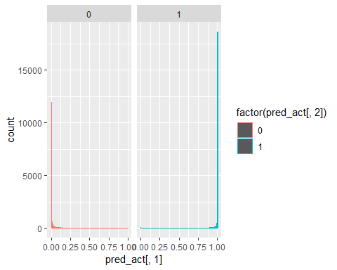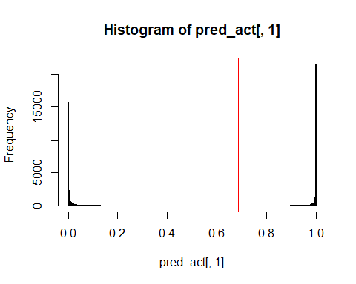

## [1] "Electron Efficiency: 0.89998160299258"  
## [1] "Pion Efficiency: 0.0395126837145602"  
## Confusion Matrix and Statistics  
##   
## Reference  
## Prediction 0 1  
## 0 46988 4893  
## 1 1933 44028  
##   
## Accuracy : 0.9302   
## 95% CI : (0.9286, 0.9318)  
## No Information Rate : 0.5   
## P-Value [Acc > NIR] : < 2.2e-16   
##   
## Kappa : 0.8605   
##   
## Mcnemar's Test P-Value : < 2.2e-16   
##   
## Sensitivity : 0.9605   
## Specificity : 0.9000   
## Pos Pred Value : 0.9057   
## Neg Pred Value : 0.9579   
## Prevalence : 0.5000   
## Detection Rate : 0.4802   
## Detection Prevalence : 0.5303   
## Balanced Accuracy : 0.9302   
##   
## 'Positive' Class : 0   
##   
## [1] "--------------------------------------------------------------------------------------------------"  
## [1] "--------------------------------------------------------------------------------------------------"  
## [1] "model25_3"  
## [1] "--------------------------------------------------------------------------------------------------"

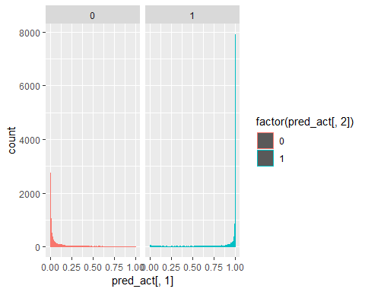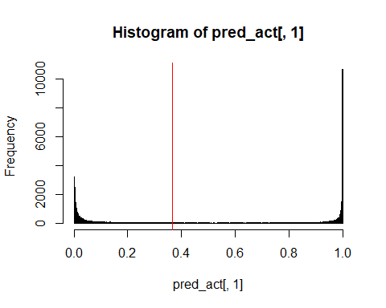

## [1] "Electron Efficiency: 0.900002044111936"  
## [1] "Pion Efficiency: 0.115431001001615"  
## Confusion Matrix and Statistics  
##   
## Reference  
## Prediction 0 1  
## 0 43274 4892  
## 1 5647 44029  
##   
## Accuracy : 0.8923   
## 95% CI : (0.8903, 0.8942)  
## No Information Rate : 0.5   
## P-Value [Acc > NIR] : < 2.2e-16   
##   
## Kappa : 0.7846   
##   
## Mcnemar's Test P-Value : 2.063e-13   
##   
## Sensitivity : 0.8846   
## Specificity : 0.9000   
## Pos Pred Value : 0.8984   
## Neg Pred Value : 0.8863   
## Prevalence : 0.5000   
## Detection Rate : 0.4423   
## Detection Prevalence : 0.4923   
## Balanced Accuracy : 0.8923   
##   
## 'Positive' Class : 0   
##   
## [1] "--------------------------------------------------------------------------------------------------"  
## [1] "--------------------------------------------------------------------------------------------------"  
## [1] "model26"  
## [1] "--------------------------------------------------------------------------------------------------"

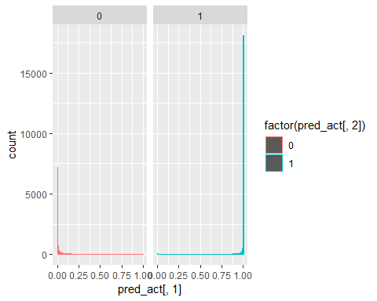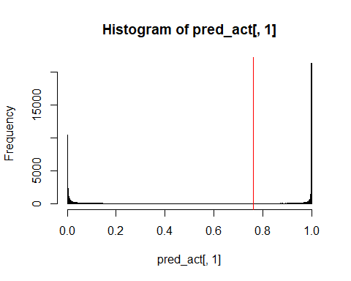

## [1] "Electron Efficiency: 0.900002044111936"  
## [1] "Pion Efficiency: 0.0454814905664234"  
## Confusion Matrix and Statistics  
##   
## Reference  
## Prediction 0 1  
## 0 46696 4892  
## 1 2225 44029  
##   
## Accuracy : 0.9273   
## 95% CI : (0.9256, 0.9289)  
## No Information Rate : 0.5   
## P-Value [Acc > NIR] : < 2.2e-16   
##   
## Kappa : 0.8545   
##   
## Mcnemar's Test P-Value : < 2.2e-16   
##   
## Sensitivity : 0.9545   
## Specificity : 0.9000   
## Pos Pred Value : 0.9052   
## Neg Pred Value : 0.9519   
## Prevalence : 0.5000   
## Detection Rate : 0.4773   
## Detection Prevalence : 0.5273   
## Balanced Accuracy : 0.9273   
##   
## 'Positive' Class : 0   
##   
## [1] "--------------------------------------------------------------------------------------------------"  
## [1] "--------------------------------------------------------------------------------------------------"  
## [1] "model27"  
## [1] "--------------------------------------------------------------------------------------------------"

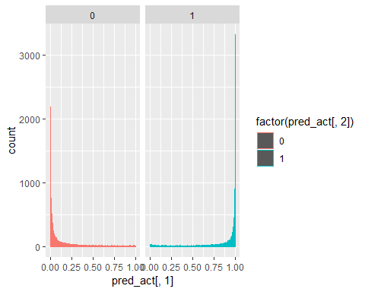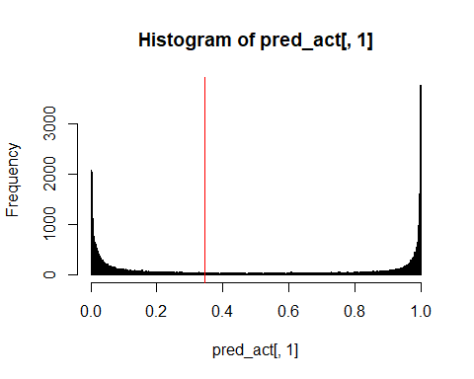

## [1] "Electron Efficiency: 0.900002044111936"  
## [1] "Pion Efficiency: 0.172707017436275"  
## Confusion Matrix and Statistics  
##   
## Reference  
## Prediction 0 1  
## 0 40472 4892  
## 1 8449 44029  
##   
## Accuracy : 0.8636   
## 95% CI : (0.8615, 0.8658)  
## No Information Rate : 0.5   
## P-Value [Acc > NIR] : < 2.2e-16   
##   
## Kappa : 0.7273   
##   
## Mcnemar's Test P-Value : < 2.2e-16   
##   
## Sensitivity : 0.8273   
## Specificity : 0.9000   
## Pos Pred Value : 0.8922   
## Neg Pred Value : 0.8390   
## Prevalence : 0.5000   
## Detection Rate : 0.4136   
## Detection Prevalence : 0.4636   
## Balanced Accuracy : 0.8636   
##   
## 'Positive' Class : 0   
##   
## [1] "--------------------------------------------------------------------------------------------------"  
## [1] "--------------------------------------------------------------------------------------------------"  
## [1] "model28"  
## [1] "--------------------------------------------------------------------------------------------------"

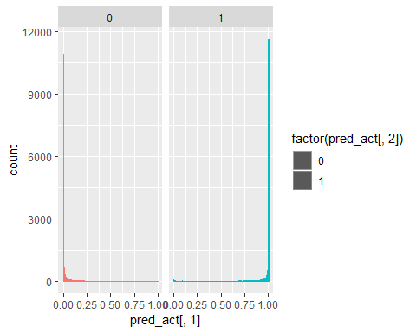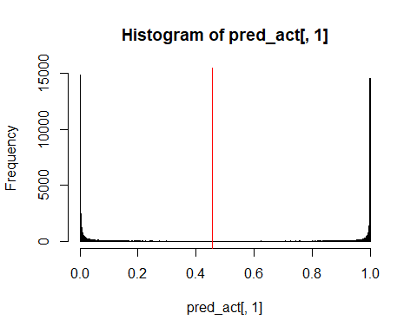

## [1] "Electron Efficiency: 0.900002044111936"  
## [1] "Pion Efficiency: 0.0583185135218005"  
## Confusion Matrix and Statistics  
##   
## Reference  
## Prediction 0 1  
## 0 46068 4892  
## 1 2853 44029  
##   
## Accuracy : 0.9208   
## 95% CI : (0.9191, 0.9225)  
## No Information Rate : 0.5   
## P-Value [Acc > NIR] : < 2.2e-16   
##   
## Kappa : 0.8417   
##   
## Mcnemar's Test P-Value : < 2.2e-16   
##   
## Sensitivity : 0.9417   
## Specificity : 0.9000   
## Pos Pred Value : 0.9040   
## Neg Pred Value : 0.9391   
## Prevalence : 0.5000   
## Detection Rate : 0.4708   
## Detection Prevalence : 0.5208   
## Balanced Accuracy : 0.9208   
##   
## 'Positive' Class : 0   
##   
## [1] "--------------------------------------------------------------------------------------------------"  
## [1] "--------------------------------------------------------------------------------------------------"  
## [1] "model29"  
## [1] "--------------------------------------------------------------------------------------------------"

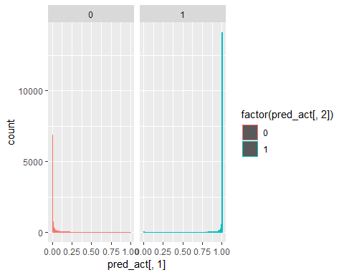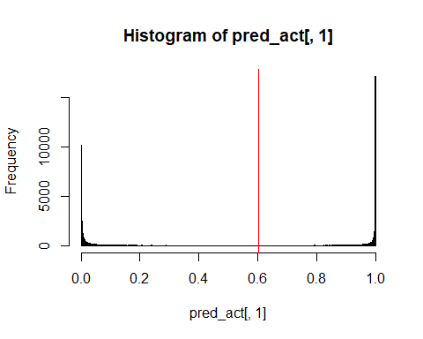

## [1] "Electron Efficiency: 0.900002044111936"  
## [1] "Pion Efficiency: 0.0592179227734511"  
## Confusion Matrix and Statistics  
##   
## Reference  
## Prediction 0 1  
## 0 46024 4892  
## 1 2897 44029  
##   
## Accuracy : 0.9204   
## 95% CI : (0.9187, 0.9221)  
## No Information Rate : 0.5   
## P-Value [Acc > NIR] : < 2.2e-16   
##   
## Kappa : 0.8408   
##   
## Mcnemar's Test P-Value : < 2.2e-16   
##   
## Sensitivity : 0.9408   
## Specificity : 0.9000   
## Pos Pred Value : 0.9039   
## Neg Pred Value : 0.9383   
## Prevalence : 0.5000   
## Detection Rate : 0.4704   
## Detection Prevalence : 0.5204   
## Balanced Accuracy : 0.9204   
##   
## 'Positive' Class : 0   
##   
## [1] "--------------------------------------------------------------------------------------------------"  
## [1] "--------------------------------------------------------------------------------------------------"  
## [1] "model30"  
## [1] "--------------------------------------------------------------------------------------------------"

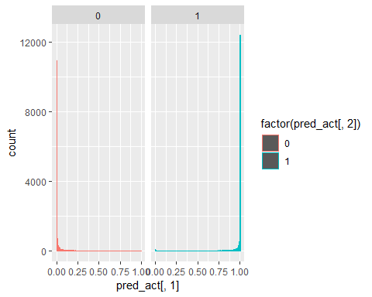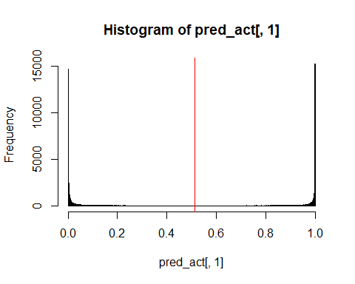

## [1] "Electron Efficiency: 0.900022485231291"  
## [1] "Pion Efficiency: 0.0530855869667423"  
## Confusion Matrix and Statistics  
##   
## Reference  
## Prediction 0 1  
## 0 46324 4891  
## 1 2597 44030  
##   
## Accuracy : 0.9235   
## 95% CI : (0.9218, 0.9251)  
## No Information Rate : 0.5   
## P-Value [Acc > NIR] : < 2.2e-16   
##   
## Kappa : 0.8469   
##   
## Mcnemar's Test P-Value : < 2.2e-16   
##   
## Sensitivity : 0.9469   
## Specificity : 0.9000   
## Pos Pred Value : 0.9045   
## Neg Pred Value : 0.9443   
## Prevalence : 0.5000   
## Detection Rate : 0.4735   
## Detection Prevalence : 0.5234   
## Balanced Accuracy : 0.9235   
##   
## 'Positive' Class : 0   
##   
## [1] "--------------------------------------------------------------------------------------------------"  
## [1] "--------------------------------------------------------------------------------------------------"  
## [1] "model31"  
## [1] "--------------------------------------------------------------------------------------------------"

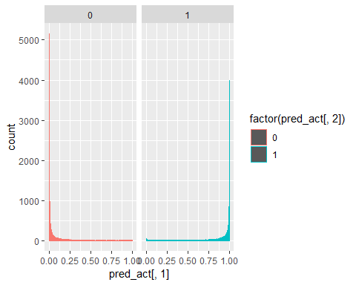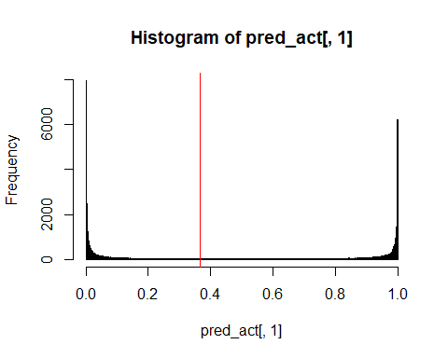

## [1] "Electron Efficiency: 0.900002044111936"  
## [1] "Pion Efficiency: 0.105578381472169"  
## Confusion Matrix and Statistics  
##   
## Reference  
## Prediction 0 1  
## 0 43756 4892  
## 1 5165 44029  
##   
## Accuracy : 0.8972   
## 95% CI : (0.8953, 0.8991)  
## No Information Rate : 0.5   
## P-Value [Acc > NIR] : < 2.2e-16   
##   
## Kappa : 0.7944   
##   
## Mcnemar's Test P-Value : 0.006682   
##   
## Sensitivity : 0.8944   
## Specificity : 0.9000   
## Pos Pred Value : 0.8994   
## Neg Pred Value : 0.8950   
## Prevalence : 0.5000   
## Detection Rate : 0.4472   
## Detection Prevalence : 0.4972   
## Balanced Accuracy : 0.8972   
##   
## 'Positive' Class : 0   
##   
## [1] "--------------------------------------------------------------------------------------------------"  
## [1] "--------------------------------------------------------------------------------------------------"  
## [1] "model32"  
## [1] "--------------------------------------------------------------------------------------------------"

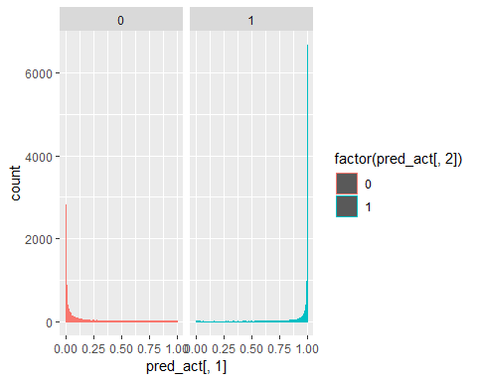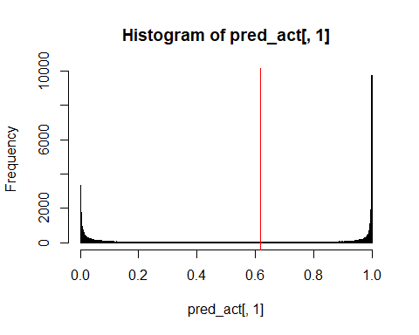

## [1] "Electron Efficiency: 0.899940720753868"  
## [1] "Pion Efficiency: 0.104965147891499"  
## Confusion Matrix and Statistics  
##   
## Reference  
## Prediction 0 1  
## 0 43786 4895  
## 1 5135 44026  
##   
## Accuracy : 0.8975   
## 95% CI : (0.8956, 0.8994)  
## No Information Rate : 0.5   
## P-Value [Acc > NIR] : < 2e-16   
##   
## Kappa : 0.795   
##   
## Mcnemar's Test P-Value : 0.01701   
##   
## Sensitivity : 0.8950   
## Specificity : 0.8999   
## Pos Pred Value : 0.8994   
## Neg Pred Value : 0.8955   
## Prevalence : 0.5000   
## Detection Rate : 0.4475   
## Detection Prevalence : 0.4975   
## Balanced Accuracy : 0.8975   
##   
## 'Positive' Class : 0   
##   
## [1] "--------------------------------------------------------------------------------------------------"  
## [1] "--------------------------------------------------------------------------------------------------"  
## [1] "model33"  
## [1] "--------------------------------------------------------------------------------------------------"

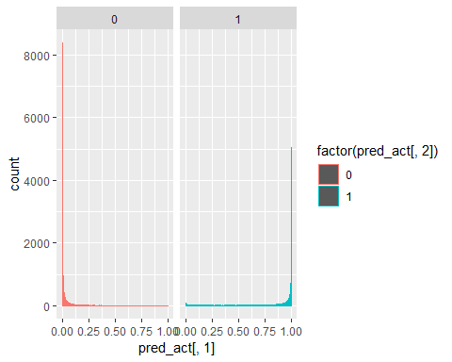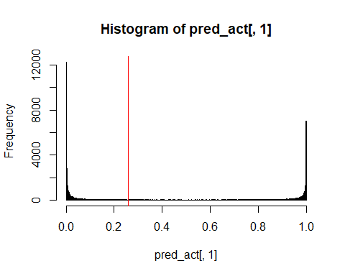

## [1] "Electron Efficiency: 0.900002044111936"  
## [1] "Pion Efficiency: 0.0855869667422988"  
## Confusion Matrix and Statistics  
##   
## Reference  
## Prediction 0 1  
## 0 44734 4892  
## 1 4187 44029  
##   
## Accuracy : 0.9072   
## 95% CI : (0.9054, 0.909)  
## No Information Rate : 0.5   
## P-Value [Acc > NIR] : < 2.2e-16   
##   
## Kappa : 0.8144   
##   
## Mcnemar's Test P-Value : 1.485e-13   
##   
## Sensitivity : 0.9144   
## Specificity : 0.9000   
## Pos Pred Value : 0.9014   
## Neg Pred Value : 0.9132   
## Prevalence : 0.5000   
## Detection Rate : 0.4572   
## Detection Prevalence : 0.5072   
## Balanced Accuracy : 0.9072   
##   
## 'Positive' Class : 0   
##   
## [1] "--------------------------------------------------------------------------------------------------"  
## [1] "--------------------------------------------------------------------------------------------------"  
## [1] "model34"  
## [1] "--------------------------------------------------------------------------------------------------"

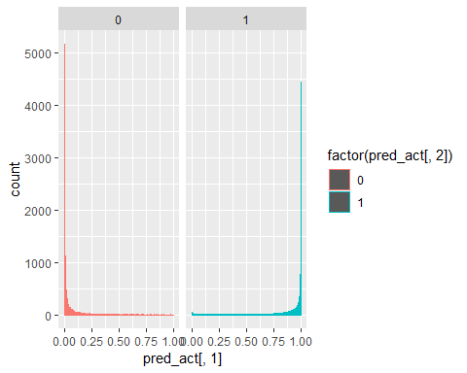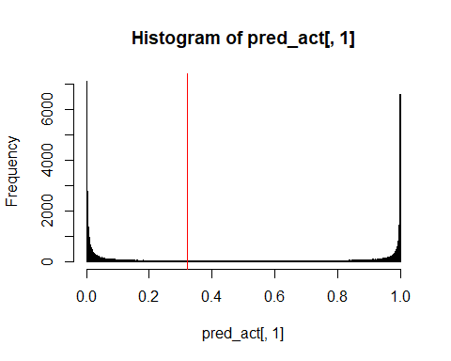

## [1] "Electron Efficiency: 0.899940720753868"  
## [1] "Pion Efficiency: 0.0948263526910734"  
## Confusion Matrix and Statistics  
##   
## Reference  
## Prediction 0 1  
## 0 44282 4895  
## 1 4639 44026  
##   
## Accuracy : 0.9026   
## 95% CI : (0.9007, 0.9044)  
## No Information Rate : 0.5   
## P-Value [Acc > NIR] : < 2.2e-16   
##   
## Kappa : 0.8051   
##   
## Mcnemar's Test P-Value : 0.009013   
##   
## Sensitivity : 0.9052   
## Specificity : 0.8999   
## Pos Pred Value : 0.9005   
## Neg Pred Value : 0.9047   
## Prevalence : 0.5000   
## Detection Rate : 0.4526   
## Detection Prevalence : 0.5026   
## Balanced Accuracy : 0.9026   
##   
## 'Positive' Class : 0   
##   
## [1] "--------------------------------------------------------------------------------------------------"  
## [1] "--------------------------------------------------------------------------------------------------"  
## [1] "model35"  
## [1] "--------------------------------------------------------------------------------------------------"

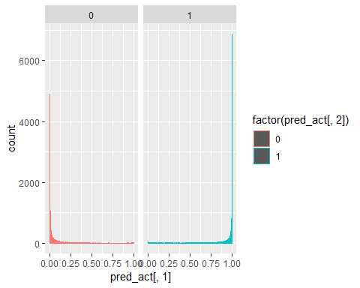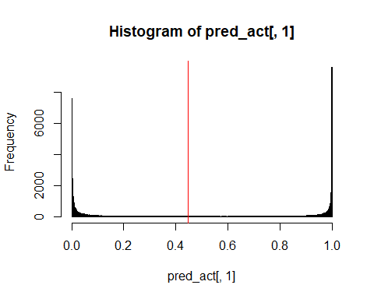

## [1] "Electron Efficiency: 0.900042926350647"  
## [1] "Pion Efficiency: 0.0892254859876127"  
## Confusion Matrix and Statistics  
##   
## Reference  
## Prediction 0 1  
## 0 44556 4890  
## 1 4365 44031  
##   
## Accuracy : 0.9054   
## 95% CI : (0.9036, 0.9072)  
## No Information Rate : 0.5   
## P-Value [Acc > NIR] : < 2.2e-16   
##   
## Kappa : 0.8108   
##   
## Mcnemar's Test P-Value : 5.128e-08   
##   
## Sensitivity : 0.9108   
## Specificity : 0.9000   
## Pos Pred Value : 0.9011   
## Neg Pred Value : 0.9098   
## Prevalence : 0.5000   
## Detection Rate : 0.4554   
## Detection Prevalence : 0.5054   
## Balanced Accuracy : 0.9054   
##   
## 'Positive' Class : 0   
##   
## [1] "--------------------------------------------------------------------------------------------------"  
## [1] "--------------------------------------------------------------------------------------------------"  
## [1] "model36"  
## [1] "--------------------------------------------------------------------------------------------------"

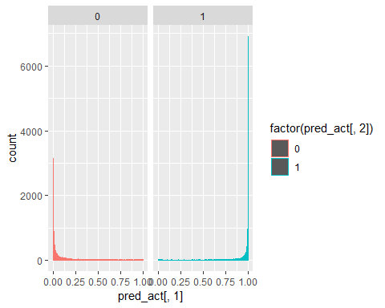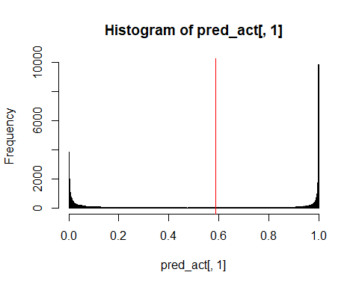

## [1] "Electron Efficiency: 0.899961161873224"  
## [1] "Pion Efficiency: 0.096461642239529"  
## Confusion Matrix and Statistics  
##   
## Reference  
## Prediction 0 1  
## 0 44202 4894  
## 1 4719 44027  
##   
## Accuracy : 0.9017   
## 95% CI : (0.8999, 0.9036)  
## No Information Rate : 0.5   
## P-Value [Acc > NIR] : < 2e-16   
##   
## Kappa : 0.8035   
##   
## Mcnemar's Test P-Value : 0.07595   
##   
## Sensitivity : 0.9035   
## Specificity : 0.9000   
## Pos Pred Value : 0.9003   
## Neg Pred Value : 0.9032   
## Prevalence : 0.5000   
## Detection Rate : 0.4518   
## Detection Prevalence : 0.5018   
## Balanced Accuracy : 0.9017   
##   
## 'Positive' Class : 0   
##   
## [1] "--------------------------------------------------------------------------------------------------"  
## [1] "--------------------------------------------------------------------------------------------------"  
## [1] "model37"  
## [1] "--------------------------------------------------------------------------------------------------"

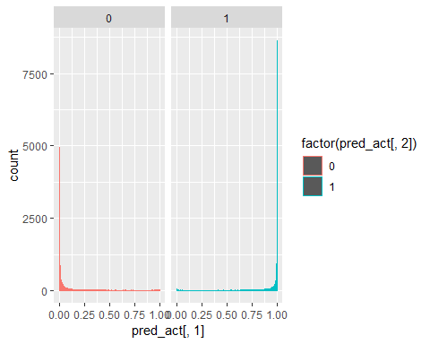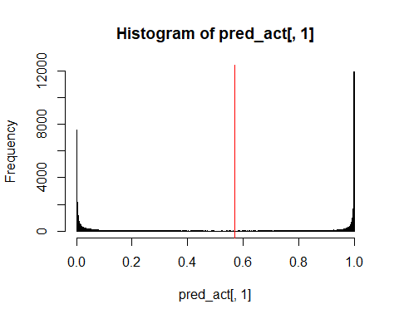

## [1] "Electron Efficiency: 0.900022485231291"  
## [1] "Pion Efficiency: 0.0923529772490342"  
## Confusion Matrix and Statistics  
##   
## Reference  
## Prediction 0 1  
## 0 44403 4891  
## 1 4518 44030  
##   
## Accuracy : 0.9038   
## 95% CI : (0.902, 0.9057)  
## No Information Rate : 0.5   
## P-Value [Acc > NIR] : < 2.2e-16   
##   
## Kappa : 0.8077   
##   
## Mcnemar's Test P-Value : 0.0001255   
##   
## Sensitivity : 0.9076   
## Specificity : 0.9000   
## Pos Pred Value : 0.9008   
## Neg Pred Value : 0.9069   
## Prevalence : 0.5000   
## Detection Rate : 0.4538   
## Detection Prevalence : 0.5038   
## Balanced Accuracy : 0.9038   
##   
## 'Positive' Class : 0   
##   
## [1] "--------------------------------------------------------------------------------------------------"  
## [1] "--------------------------------------------------------------------------------------------------"  
## [1] "model38"  
## [1] "--------------------------------------------------------------------------------------------------"

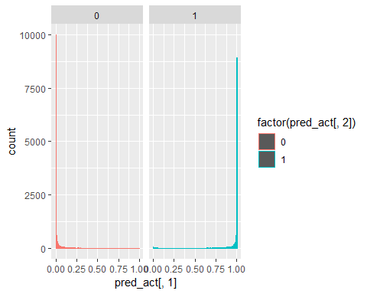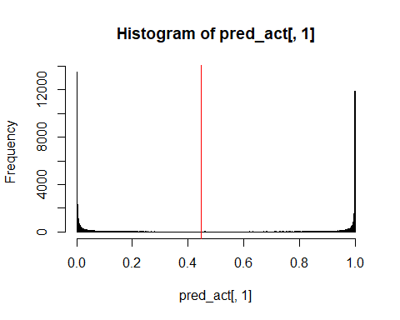

## [1] "Electron Efficiency: 0.900002044111936"  
## [1] "Pion Efficiency: 0.0761022873612559"  
## Confusion Matrix and Statistics  
##   
## Reference  
## Prediction 0 1  
## 0 45198 4892  
## 1 3723 44029  
##   
## Accuracy : 0.9119   
## 95% CI : (0.9102, 0.9137)  
## No Information Rate : 0.5   
## P-Value [Acc > NIR] : < 2.2e-16   
##   
## Kappa : 0.8239   
##   
## Mcnemar's Test P-Value : < 2.2e-16   
##   
## Sensitivity : 0.9239   
## Specificity : 0.9000   
## Pos Pred Value : 0.9023   
## Neg Pred Value : 0.9220   
## Prevalence : 0.5000   
## Detection Rate : 0.4619   
## Detection Prevalence : 0.5119   
## Balanced Accuracy : 0.9119   
##   
## 'Positive' Class : 0   
##   
## [1] "--------------------------------------------------------------------------------------------------"  
## [1] "--------------------------------------------------------------------------------------------------"  
## [1] "model39"  
## [1] "--------------------------------------------------------------------------------------------------"

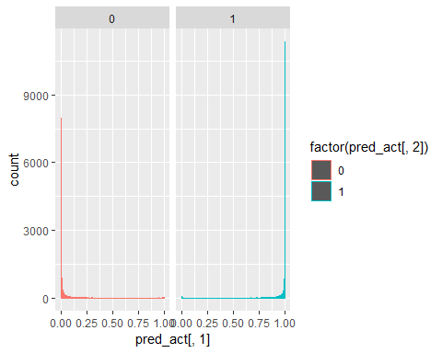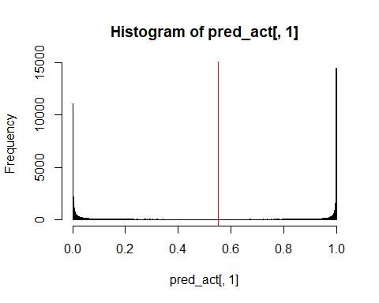

## [1] "Electron Efficiency: 0.900002044111936"  
## [1] "Pion Efficiency: 0.0825412399583001"  
## Confusion Matrix and Statistics  
##   
## Reference  
## Prediction 0 1  
## 0 44883 4892  
## 1 4038 44029  
##   
## Accuracy : 0.9087   
## 95% CI : (0.9069, 0.9105)  
## No Information Rate : 0.5   
## P-Value [Acc > NIR] : < 2.2e-16   
##   
## Kappa : 0.8175   
##   
## Mcnemar's Test P-Value : < 2.2e-16   
##   
## Sensitivity : 0.9175   
## Specificity : 0.9000   
## Pos Pred Value : 0.9017   
## Neg Pred Value : 0.9160   
## Prevalence : 0.5000   
## Detection Rate : 0.4587   
## Detection Prevalence : 0.5087   
## Balanced Accuracy : 0.9087   
##   
## 'Positive' Class : 0   
##   
## [1] "--------------------------------------------------------------------------------------------------"  
## [1] "--------------------------------------------------------------------------------------------------"  
## [1] "model40"  
## [1] "--------------------------------------------------------------------------------------------------"

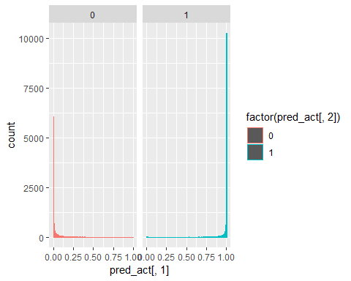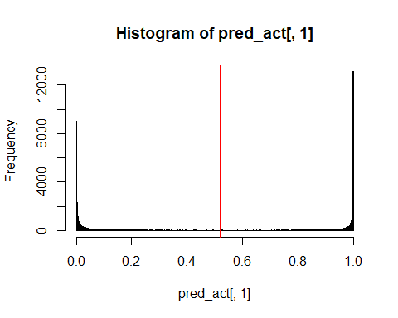

## [1] "Electron Efficiency: 0.900002044111936"  
## [1] "Pion Efficiency: 0.077369636761309"  
## Confusion Matrix and Statistics  
##   
## Reference  
## Prediction 0 1  
## 0 45136 4892  
## 1 3785 44029  
##   
## Accuracy : 0.9113   
## 95% CI : (0.9095, 0.9131)  
## No Information Rate : 0.5   
## P-Value [Acc > NIR] : < 2.2e-16   
##   
## Kappa : 0.8226   
##   
## Mcnemar's Test P-Value : < 2.2e-16   
##   
## Sensitivity : 0.9226   
## Specificity : 0.9000   
## Pos Pred Value : 0.9022   
## Neg Pred Value : 0.9208   
## Prevalence : 0.5000   
## Detection Rate : 0.4613   
## Detection Prevalence : 0.5113   
## Balanced Accuracy : 0.9113   
##   
## 'Positive' Class : 0   
##   
## [1] "--------------------------------------------------------------------------------------------------"  
## [1] "--------------------------------------------------------------------------------------------------"  
## [1] "model41"  
## [1] "--------------------------------------------------------------------------------------------------"

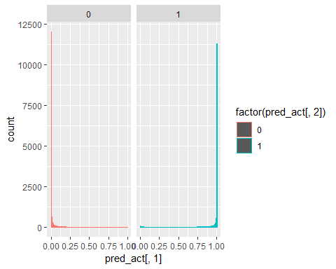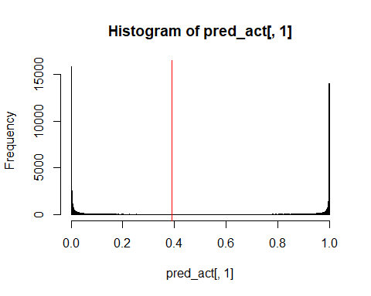

## [1] "Electron Efficiency: 0.900002044111936"  
## [1] "Pion Efficiency: 0.0654933464156497"  
## Confusion Matrix and Statistics  
##   
## Reference  
## Prediction 0 1  
## 0 45717 4892  
## 1 3204 44029  
##   
## Accuracy : 0.9173   
## 95% CI : (0.9155, 0.919)  
## No Information Rate : 0.5   
## P-Value [Acc > NIR] : < 2.2e-16   
##   
## Kappa : 0.8345   
##   
## Mcnemar's Test P-Value : < 2.2e-16   
##   
## Sensitivity : 0.9345   
## Specificity : 0.9000   
## Pos Pred Value : 0.9033   
## Neg Pred Value : 0.9322   
## Prevalence : 0.5000   
## Detection Rate : 0.4673   
## Detection Prevalence : 0.5173   
## Balanced Accuracy : 0.9173   
##   
## 'Positive' Class : 0   
##   
## [1] "--------------------------------------------------------------------------------------------------"  
## [1] "--------------------------------------------------------------------------------------------------"  
## [1] "model42"  
## [1] "--------------------------------------------------------------------------------------------------"

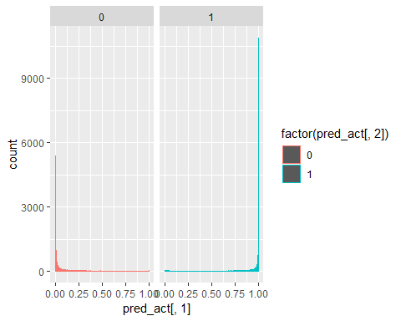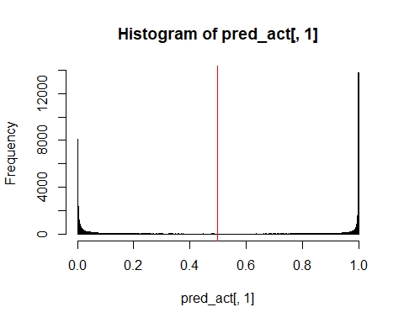

## [1] "Electron Efficiency: 0.900002044111936"  
## [1] "Pion Efficiency: 0.0898796018069949"  
## Confusion Matrix and Statistics  
##   
## Reference  
## Prediction 0 1  
## 0 44524 4892  
## 1 4397 44029  
##   
## Accuracy : 0.9051   
## 95% CI : (0.9032, 0.9069)  
## No Information Rate : 0.5   
## P-Value [Acc > NIR] : < 2.2e-16   
##   
## Kappa : 0.8101   
##   
## Mcnemar's Test P-Value : 2.966e-07   
##   
## Sensitivity : 0.9101   
## Specificity : 0.9000   
## Pos Pred Value : 0.9010   
## Neg Pred Value : 0.9092   
## Prevalence : 0.5000   
## Detection Rate : 0.4551   
## Detection Prevalence : 0.5051   
## Balanced Accuracy : 0.9051   
##   
## 'Positive' Class : 0   
##   
## [1] "--------------------------------------------------------------------------------------------------"  
## [1] "--------------------------------------------------------------------------------------------------"  
## [1] "model43"  
## [1] "--------------------------------------------------------------------------------------------------"

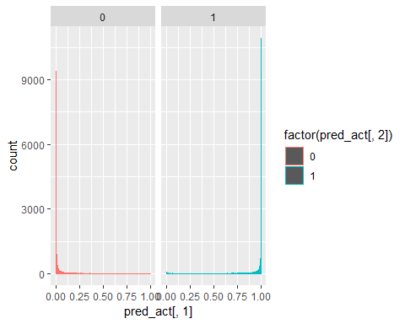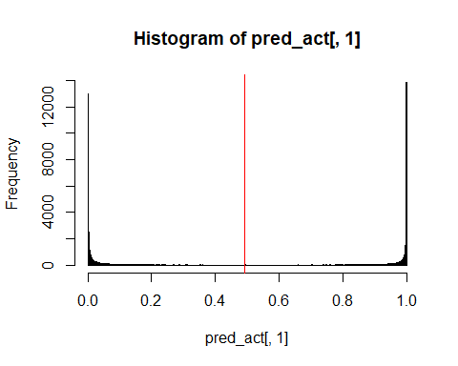

## [1] "Electron Efficiency: 0.900042926350647"  
## [1] "Pion Efficiency: 0.0581754256863106"  
## Confusion Matrix and Statistics  
##   
## Reference  
## Prediction 0 1  
## 0 46075 4890  
## 1 2846 44031  
##   
## Accuracy : 0.9209   
## 95% CI : (0.9192, 0.9226)  
## No Information Rate : 0.5   
## P-Value [Acc > NIR] : < 2.2e-16   
##   
## Kappa : 0.8419   
##   
## Mcnemar's Test P-Value : < 2.2e-16   
##   
## Sensitivity : 0.9418   
## Specificity : 0.9000   
## Pos Pred Value : 0.9041   
## Neg Pred Value : 0.9393   
## Prevalence : 0.5000   
## Detection Rate : 0.4709   
## Detection Prevalence : 0.5209   
## Balanced Accuracy : 0.9209   
##   
## 'Positive' Class : 0   
##   
## [1] "--------------------------------------------------------------------------------------------------"  
## [1] "--------------------------------------------------------------------------------------------------"  
## [1] "model44"  
## [1] "--------------------------------------------------------------------------------------------------"

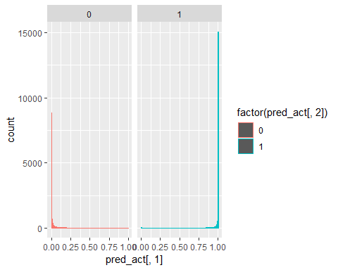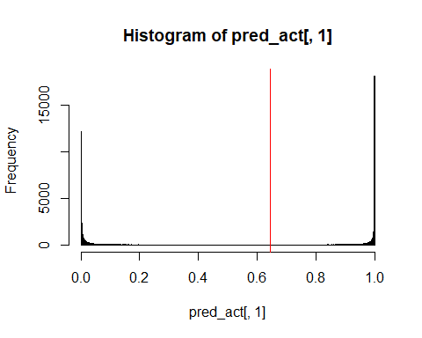

## [1] "Electron Efficiency: 0.900002044111936"  
## [1] "Pion Efficiency: 0.0530242636086752"  
## Confusion Matrix and Statistics  
##   
## Reference  
## Prediction 0 1  
## 0 46327 4892  
## 1 2594 44029  
##   
## Accuracy : 0.9235   
## 95% CI : (0.9218, 0.9251)  
## No Information Rate : 0.5   
## P-Value [Acc > NIR] : < 2.2e-16   
##   
## Kappa : 0.847   
##   
## Mcnemar's Test P-Value : < 2.2e-16   
##   
## Sensitivity : 0.9470   
## Specificity : 0.9000   
## Pos Pred Value : 0.9045   
## Neg Pred Value : 0.9444   
## Prevalence : 0.5000   
## Detection Rate : 0.4735   
## Detection Prevalence : 0.5235   
## Balanced Accuracy : 0.9235   
##   
## 'Positive' Class : 0   
##   
## [1] "--------------------------------------------------------------------------------------------------"  
## [1] "--------------------------------------------------------------------------------------------------"  
## [1] "model45"  
## [1] "--------------------------------------------------------------------------------------------------"

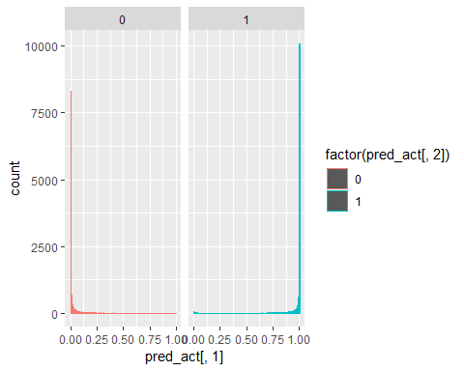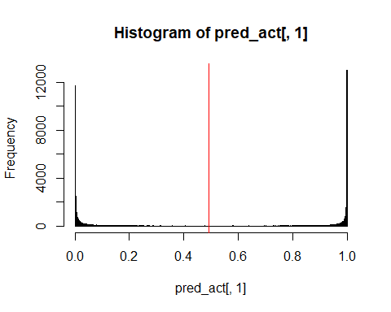

## [1] "Electron Efficiency: 0.899961161873224"  
## [1] "Pion Efficiency: 0.0659021688027636"  
## Confusion Matrix and Statistics  
##   
## Reference  
## Prediction 0 1  
## 0 45697 4894  
## 1 3224 44027  
##   
## Accuracy : 0.917   
## 95% CI : (0.9153, 0.9188)  
## No Information Rate : 0.5   
## P-Value [Acc > NIR] : < 2.2e-16   
##   
## Kappa : 0.8341   
##   
## Mcnemar's Test P-Value : < 2.2e-16   
##   
## Sensitivity : 0.9341   
## Specificity : 0.9000   
## Pos Pred Value : 0.9033   
## Neg Pred Value : 0.9318   
## Prevalence : 0.5000   
## Detection Rate : 0.4670   
## Detection Prevalence : 0.5171   
## Balanced Accuracy : 0.9170   
##   
## 'Positive' Class : 0   
##   
## [1] "--------------------------------------------------------------------------------------------------"  
## [1] "--------------------------------------------------------------------------------------------------"  
## [1] "model47"  
## [1] "--------------------------------------------------------------------------------------------------"

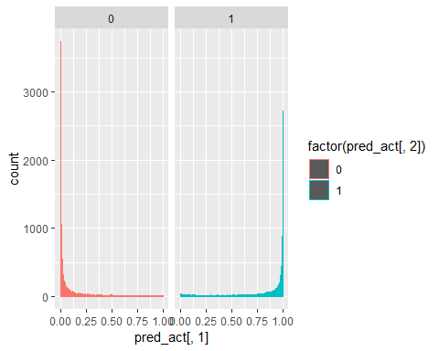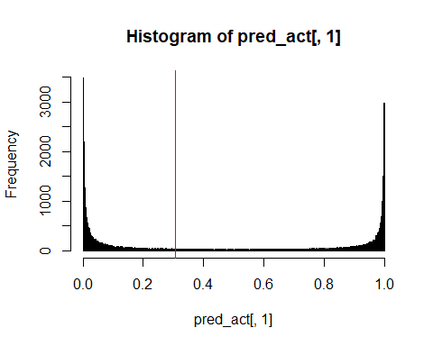

## [1] "Electron Efficiency: 0.89998160299258"  
## [1] "Pion Efficiency: 0.148647819954621"  
## Confusion Matrix and Statistics  
##   
## Reference  
## Prediction 0 1  
## 0 41649 4893  
## 1 7272 44028  
##   
## Accuracy : 0.8757   
## 95% CI : (0.8736, 0.8777)  
## No Information Rate : 0.5   
## P-Value [Acc > NIR] : < 2.2e-16   
##   
## Kappa : 0.7513   
##   
## Mcnemar's Test P-Value : < 2.2e-16   
##   
## Sensitivity : 0.8514   
## Specificity : 0.9000   
## Pos Pred Value : 0.8949   
## Neg Pred Value : 0.8582   
## Prevalence : 0.5000   
## Detection Rate : 0.4257   
## Detection Prevalence : 0.4757   
## Balanced Accuracy : 0.8757   
##   
## 'Positive' Class : 0   
##   
## [1] "--------------------------------------------------------------------------------------------------"  
## [1] "--------------------------------------------------------------------------------------------------"  
## [1] "model48"  
## [1] "--------------------------------------------------------------------------------------------------"

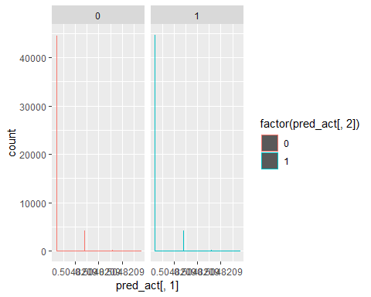

## [1] "Electron Efficiency: 1"  
## [1] "Pion Efficiency: 1"

## Warning in confusionMatrix.default(data = factor(pred_act$final_pred),  
## reference = factor(pred_act[, : Levels are not in the same order for  
## reference and data. Refactoring data to match.

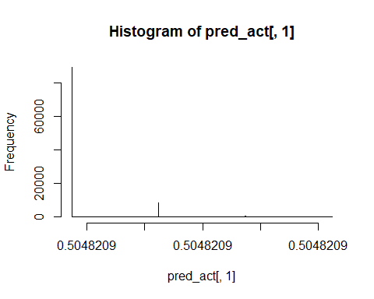

## Confusion Matrix and Statistics  
##   
## Reference  
## Prediction 0 1  
## 0 0 0  
## 1 48921 48921  
##   
## Accuracy : 0.5   
## 95% CI : (0.4969, 0.5031)  
## No Information Rate : 0.5   
## P-Value [Acc > NIR] : 0.5013   
##   
## Kappa : 0   
##   
## Mcnemar's Test P-Value : <2e-16   
##   
## Sensitivity : 0.0   
## Specificity : 1.0   
## Pos Pred Value : NaN   
## Neg Pred Value : 0.5   
## Prevalence : 0.5   
## Detection Rate : 0.0   
## Detection Prevalence : 0.0   
## Balanced Accuracy : 0.5   
##   
## 'Positive' Class : 0   
##   
## [1] "--------------------------------------------------------------------------------------------------"